**Testing/Implementation**

|  |  |
| --- | --- |
| **Function to test** | **Working?** |
| New game function on the main menu- does it start the game from the beginning using the default variable values? | Yes |
| Continue game function on the main menu- does it start the game from where the player last saved, getting variable values from the database? | Yes |
| Movement using the arrow keys while traversing the world | Yes |
| Random encounters cause the window to switch from traversal to a battle | Yes |
| Scripted events- do they trigger at the right time and does dialogue show with the cutscenes? | Yes |
| Battle functions- does the character do the correct command based on the player’s input? | Yes |
| Can the player control the party characters properly? | Yes |
| Battle functions- does the enemy attack the player’s party effectively or buff themselves to make it harder for the player to win? | Yes |
| NG+- does the player enter NG+ when they finish the game, and does the extra boss trigger in NG+? | No |
| Does the true final boss trigger when the player has found all 3 key items? | Yes |
| Does the background change colour depending on the area that you’re in? | Yes |
| Do the sidequests activate when you talk to an NPC? | Yes |
| Does the player get rewards for completing sidequests? | Yes |

There is no validation testing in here as, the way I have coded it, the game only checks for correct inputs by the player so, if there is an incorrect input, the game does nothing.

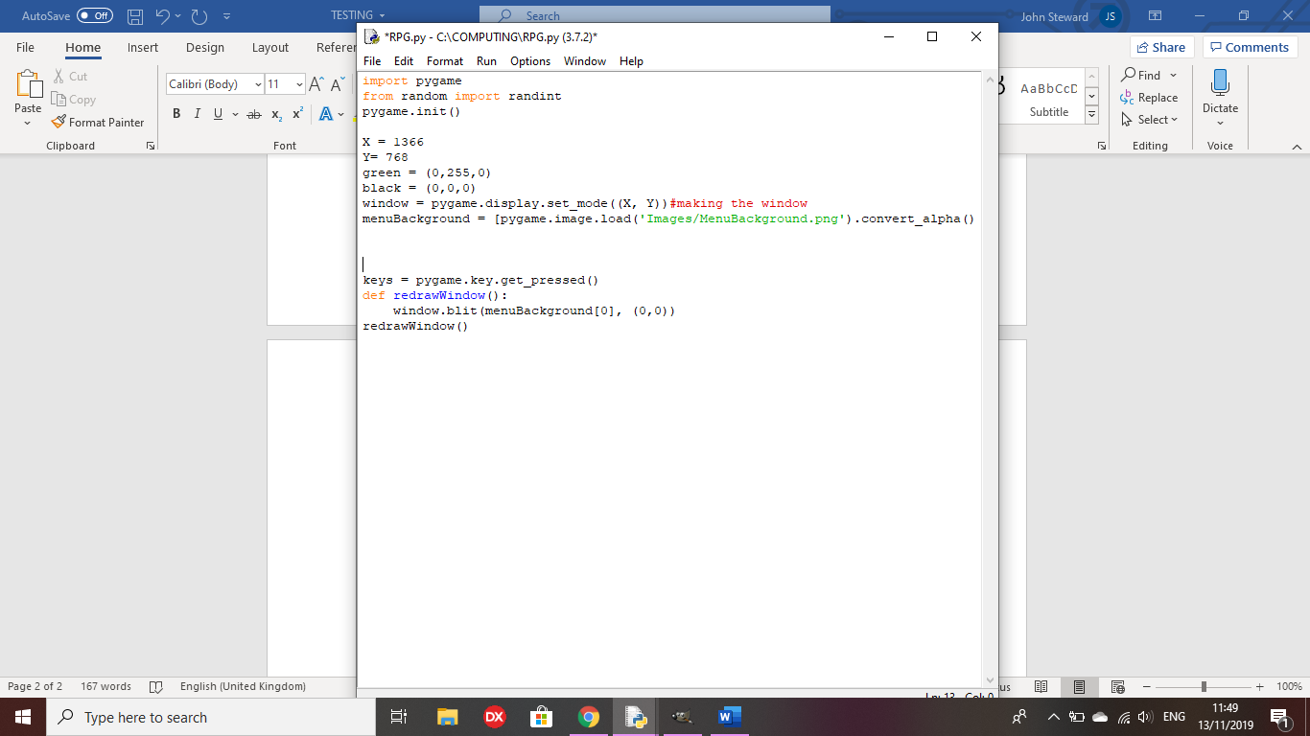Test 1: Does the main menu image appear on the game menu when the code is run?

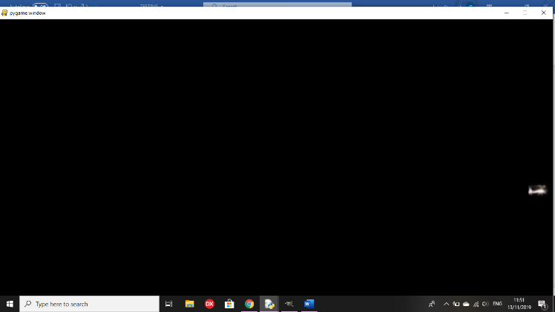

Outcome: Does not load the full image on the window

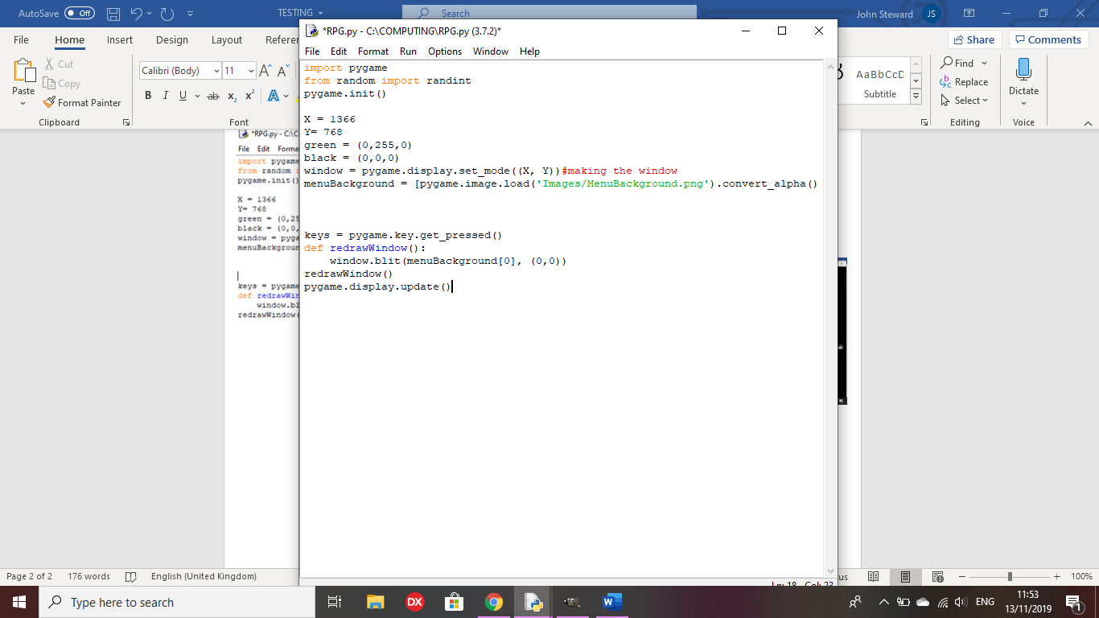

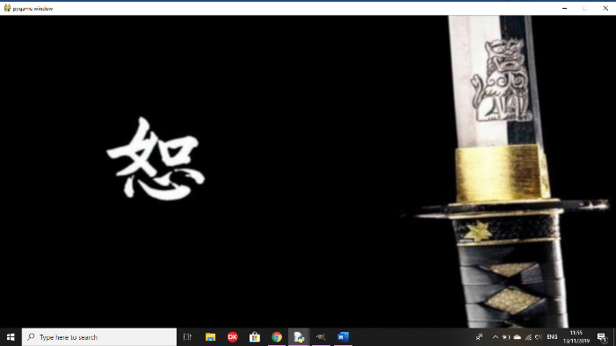

Remedy: ‘pygame.display.update()’ loads the full image onto the screen without having to move the window offscreen.

Test 2: does the text for the main menu appear on the window?

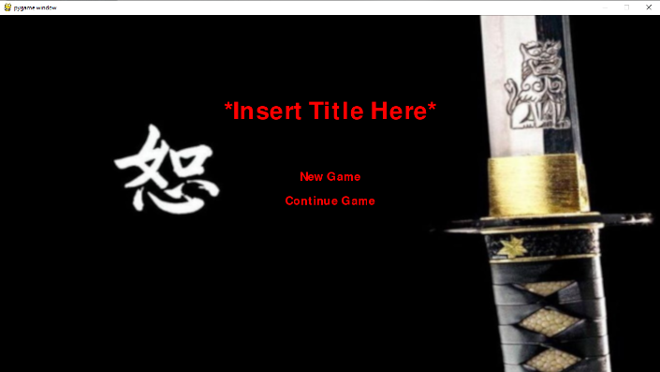

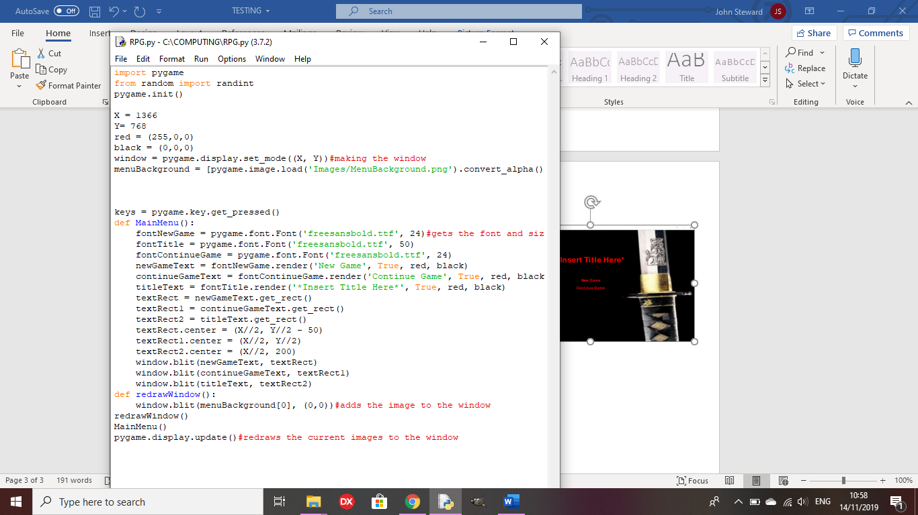

Outcome: All of the text for the main menu has now been placed, with a placeholder for the title, but neither of the options have any functions yet.

Test 3: Does the arrow cursor appear on the menu options as intended?

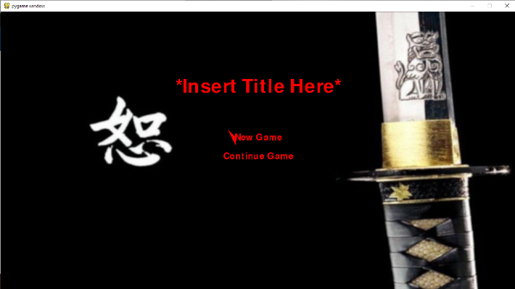

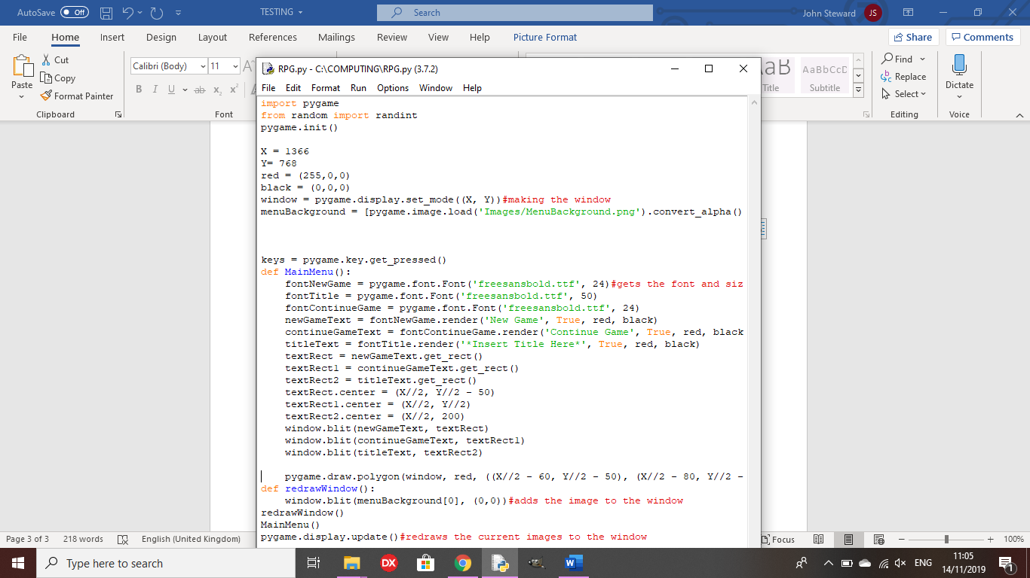

Outcome: The cursor is drawn , but the vertices are not in the correct place to be to the left of ‘New Game’

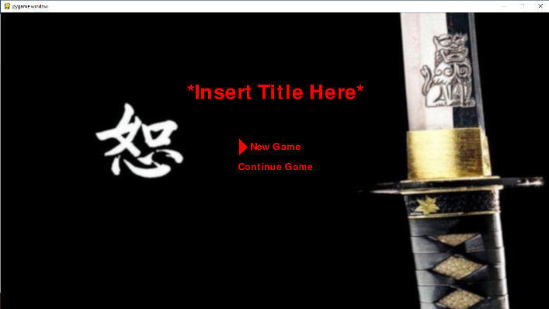

Remedy:

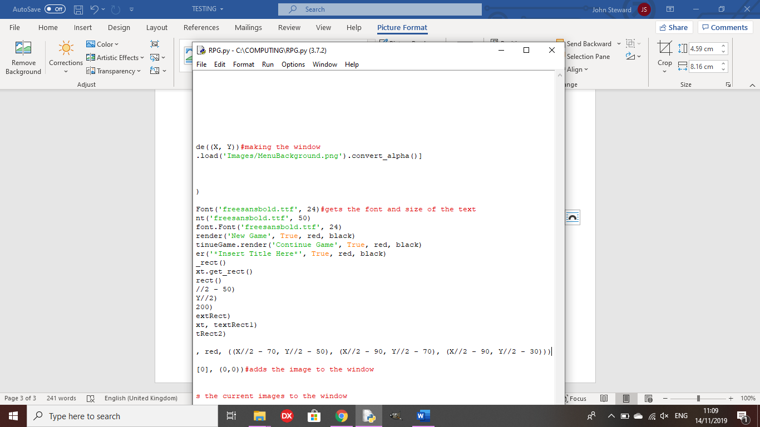

I changed the vertices of the cursor so it is drawn correctly.

Test 4: Does the cursor move from ‘New Game’ to ‘Continue Game’ when the arrow keys are pressed?

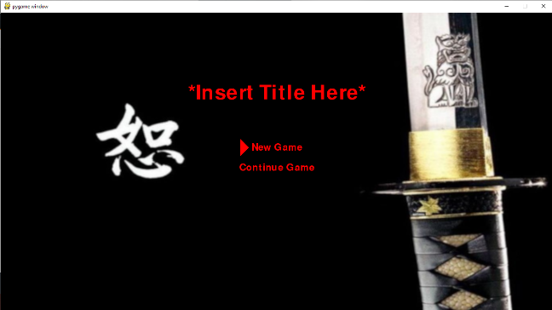

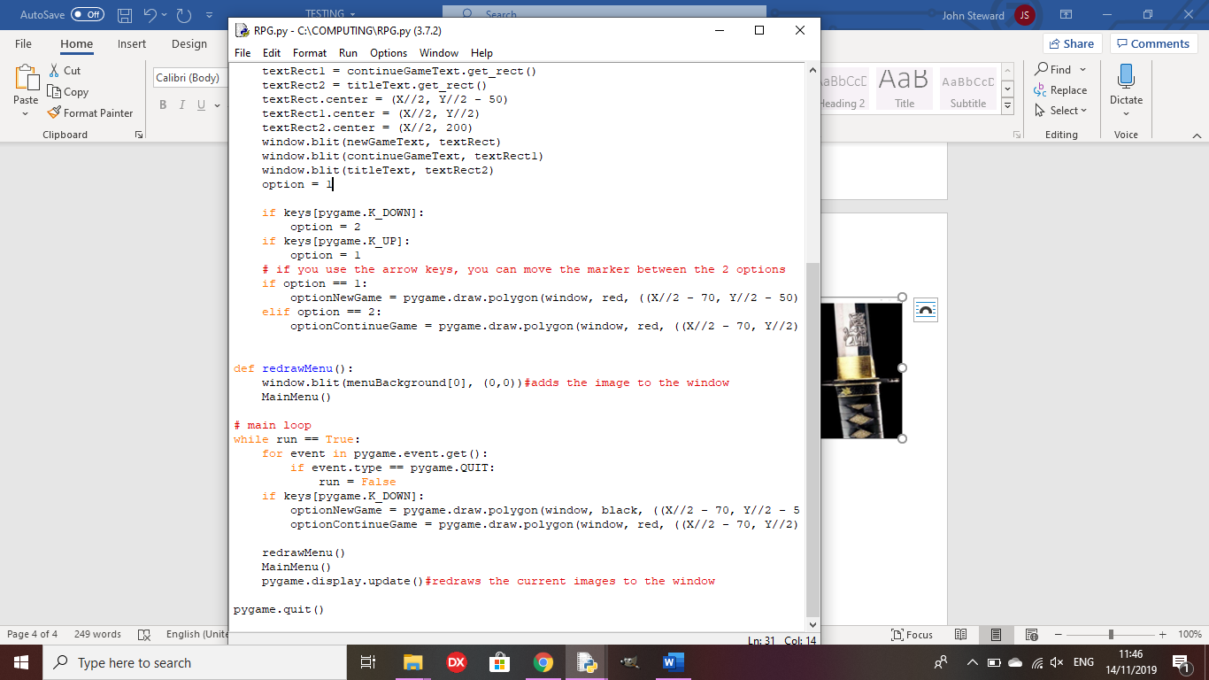

Outcome: The arrow marker should move between the 2 options as you press the arrow keys, but stays on ‘New Game’

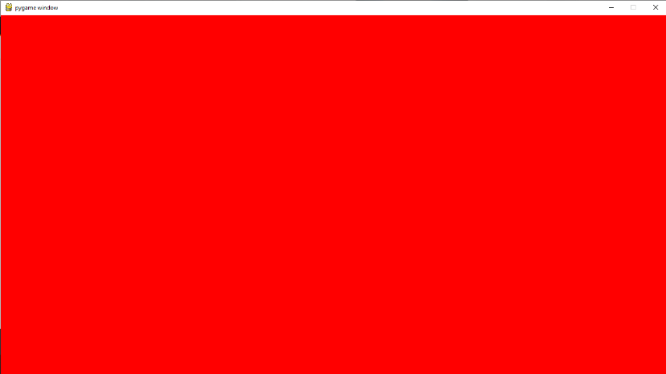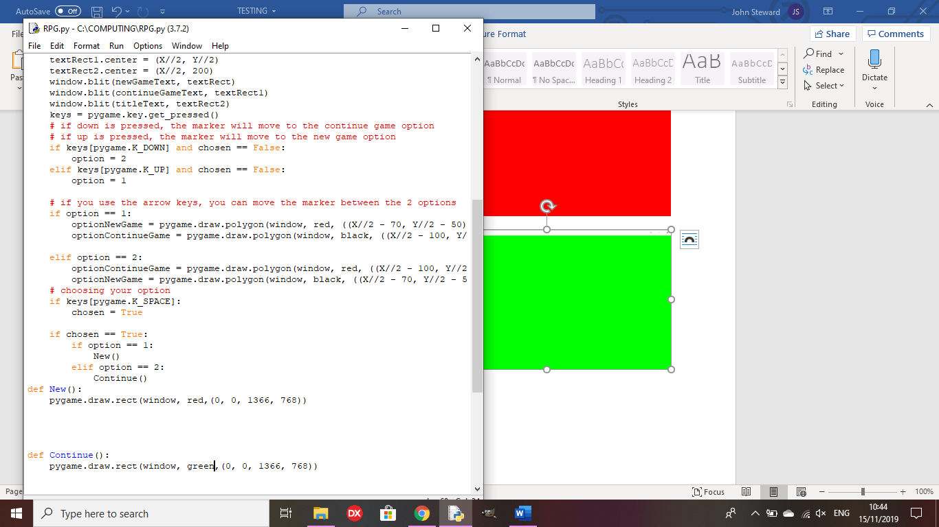Test 5: Do the new game and continue game options do as intended?

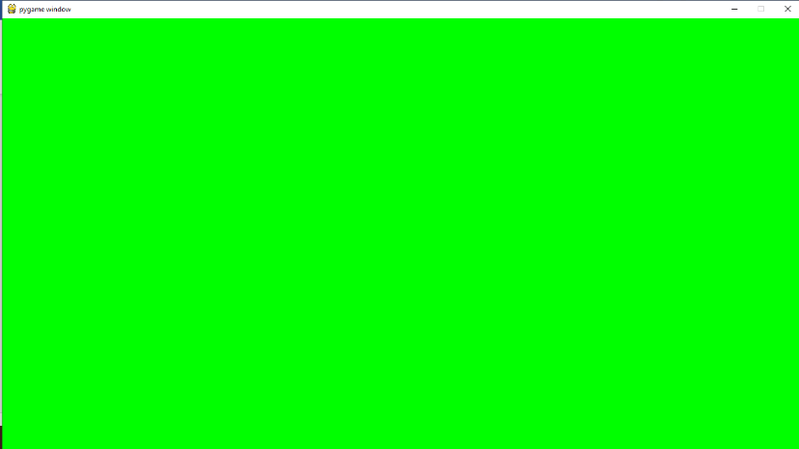

Outcome: I have used placeholders for new and continue game to show that the functions work as intended when the correct options are chosen.

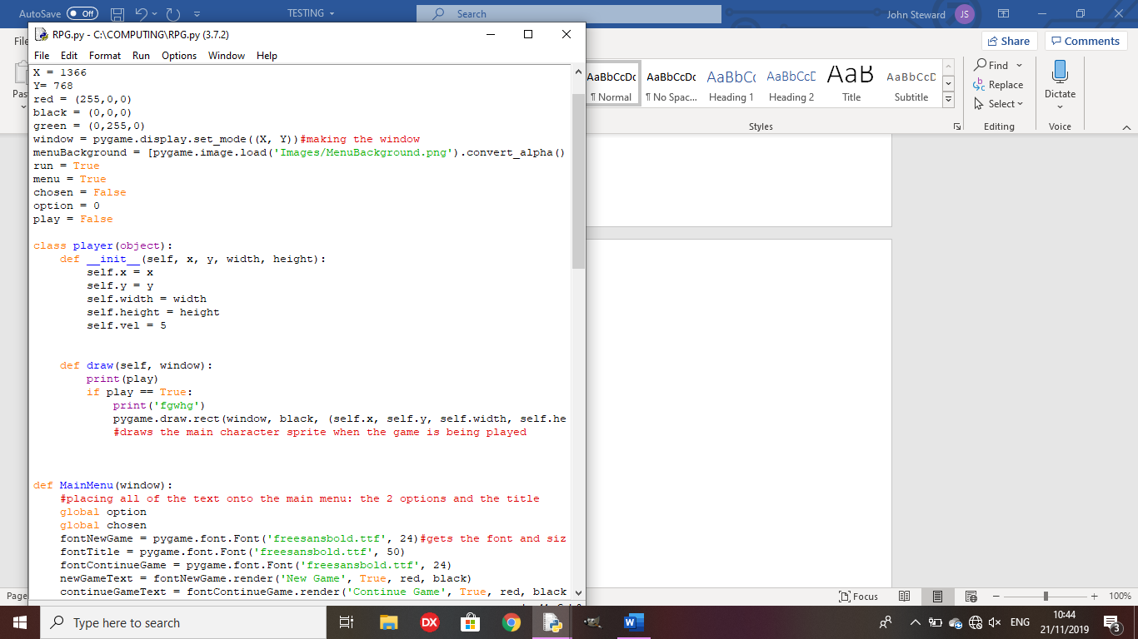

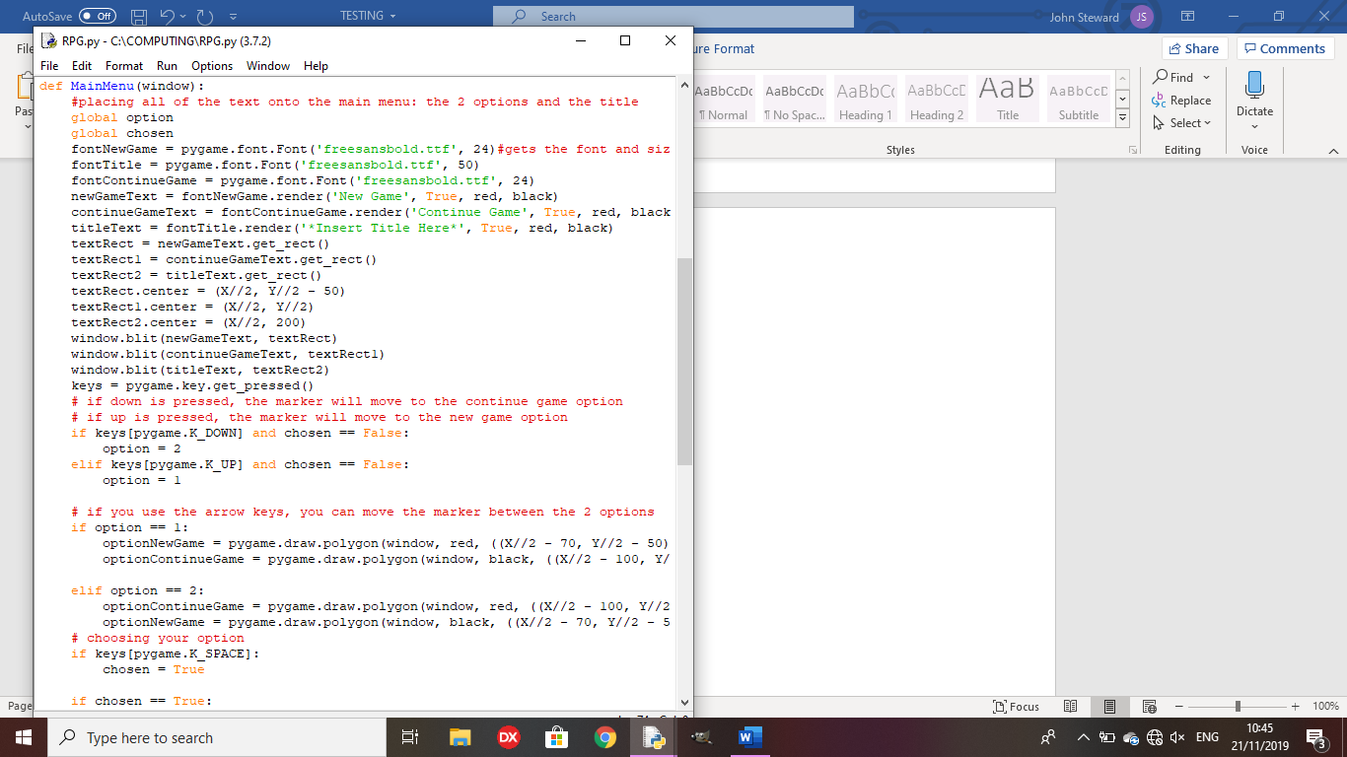**Review Point 1**

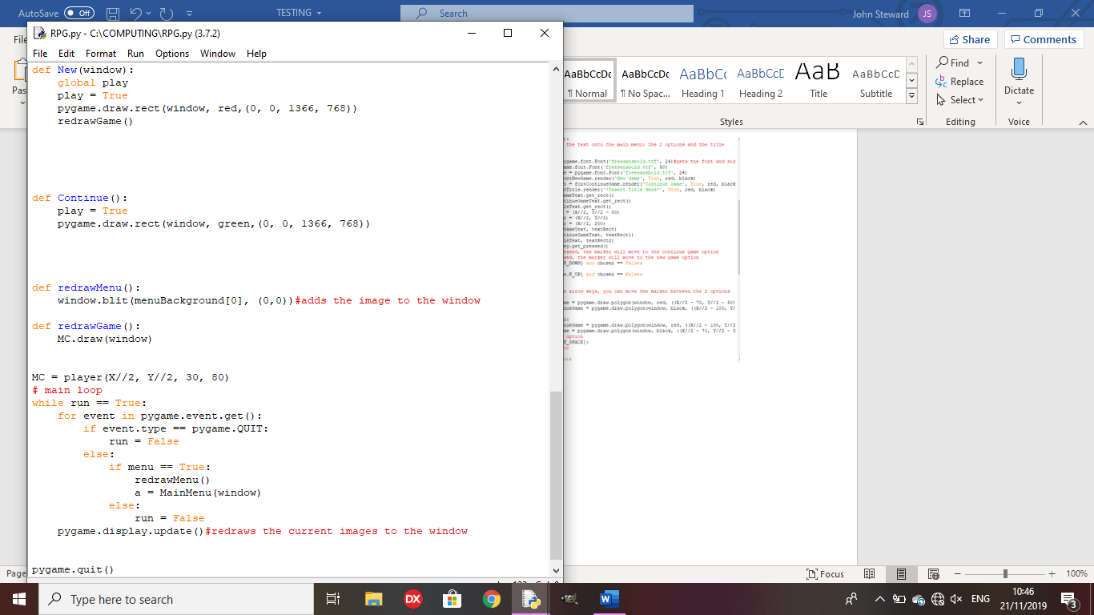

This is a good starting point for making my game, however there is a mix of OOP and external functions at the moment, making it easy to lose track of where variables are being sent to, so the code will be altered to make it so the whole code is object oriented, making it much easier to track.

Remedial action:

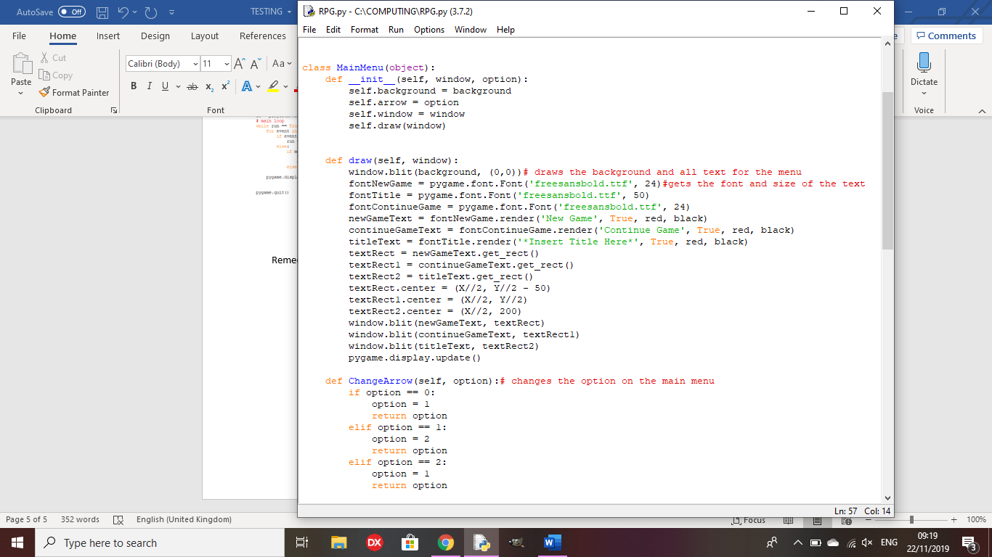

The main menu is now its own class, making it much easier to track variables going in and out of functions, and keeping the code much tidier and easier to see what is going on.

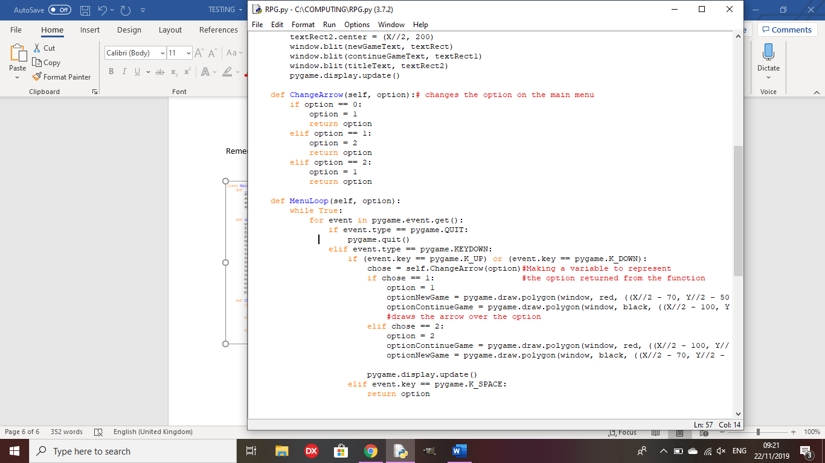

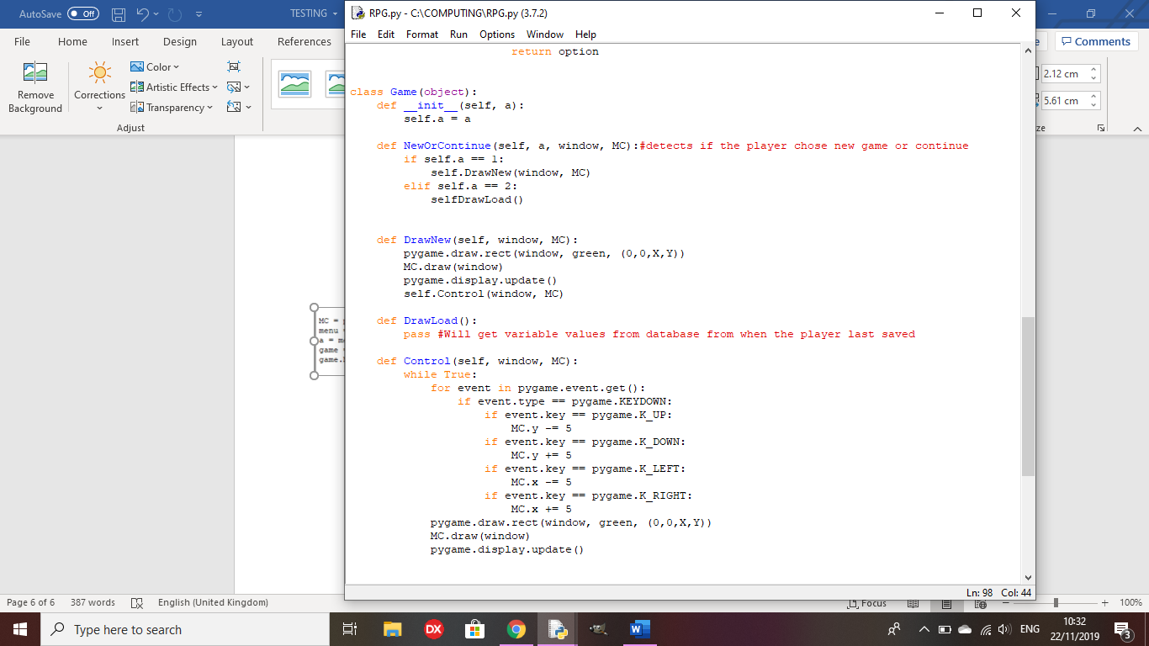Test 6: Are the character and the background drawn onscreen?

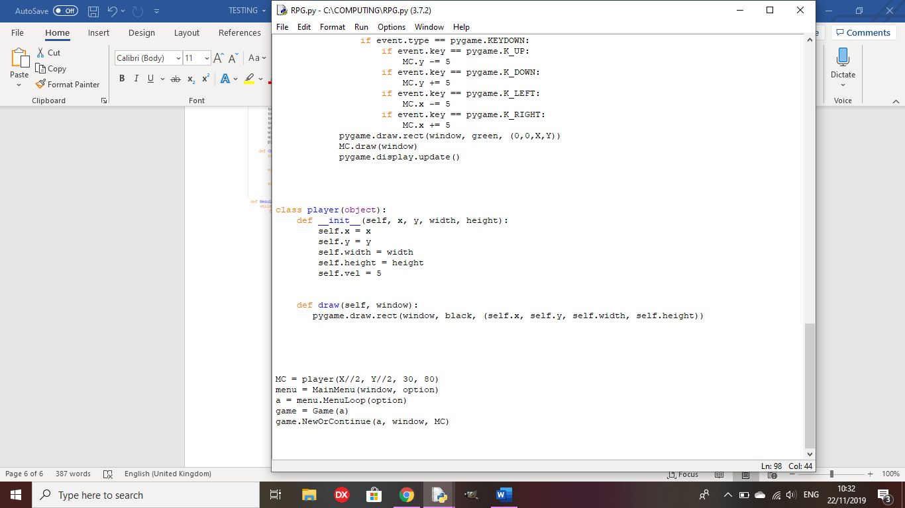

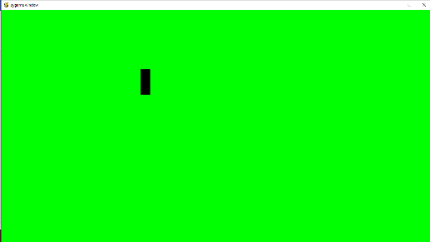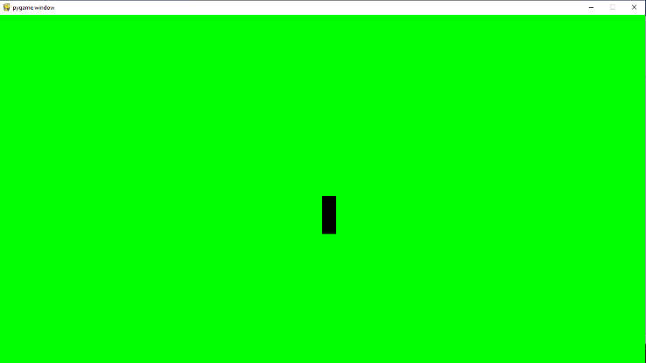

Outcome: The game now runs when the new game option is pressed, showing a green background and a character sprite being the black rectangle. The Control function allows the player to move the character using the arrow keys, as shown in the image on the right.

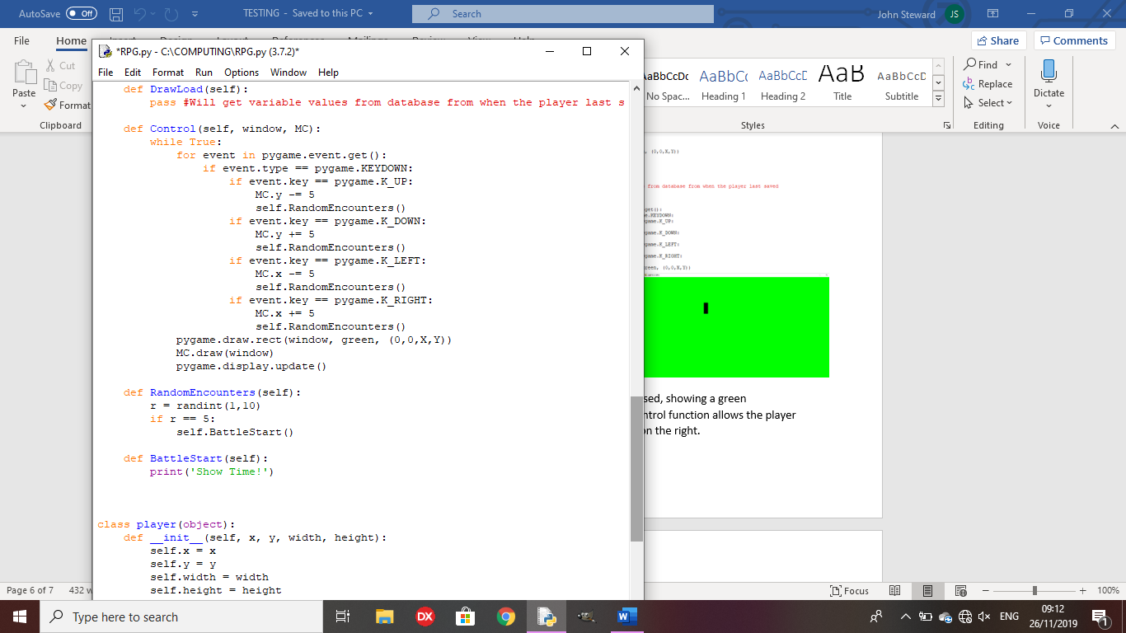Test 7: Does the character stop moving when a battle is initiated?

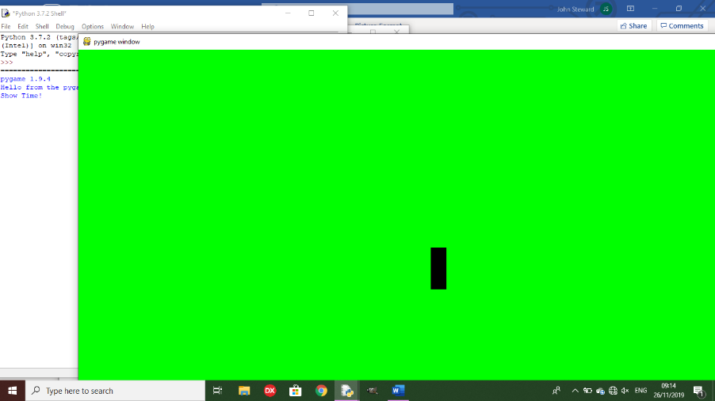

Outcome: The program goes to the BattleStart method as it should, but still allows the player to move around the space.

Remedy:

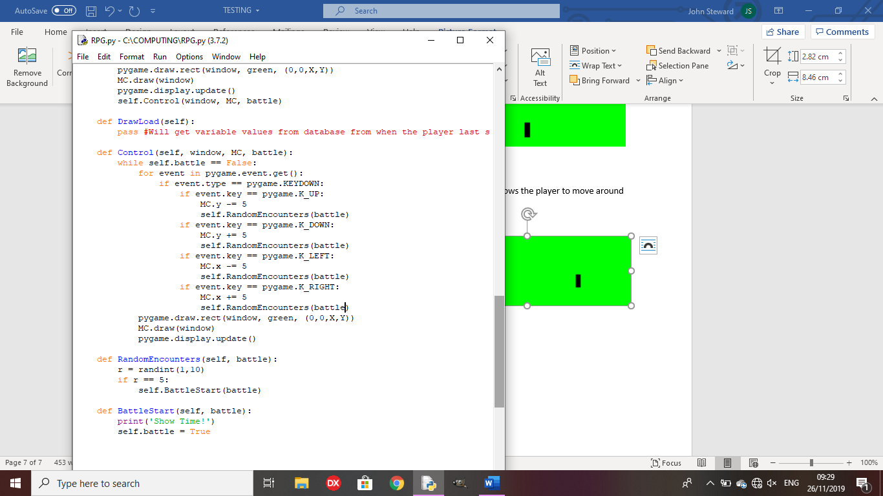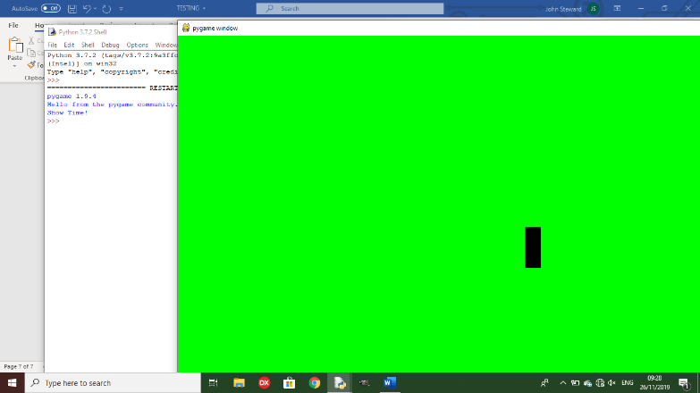

The code now ends when a random encounter is triggered, as you can no longer control the character when it is triggered, taking the game out of the control method, therefore ending the code.

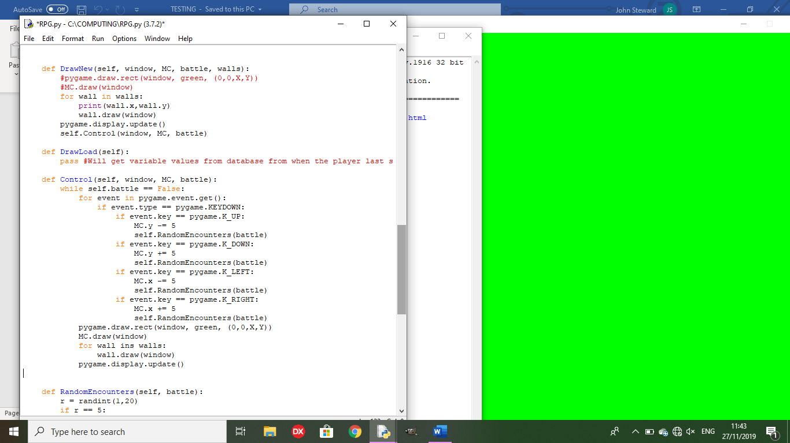The code to draw the world is repeated in the control method, making the code less efficient, so I will need to make a ‘ReDraw’ method, instead of repeating the code, to redraw every object that is or will be onscreen.

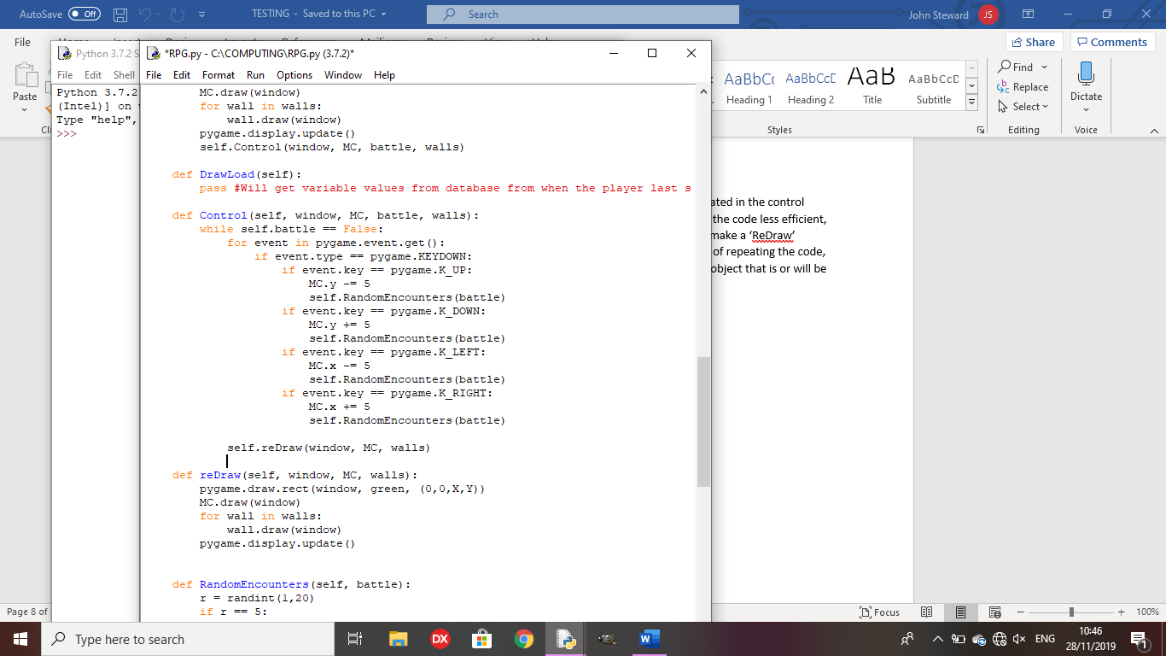

Remedy:

The code will now be more efficient since all I need to do is call the method to redraw all of the objects in the game world.

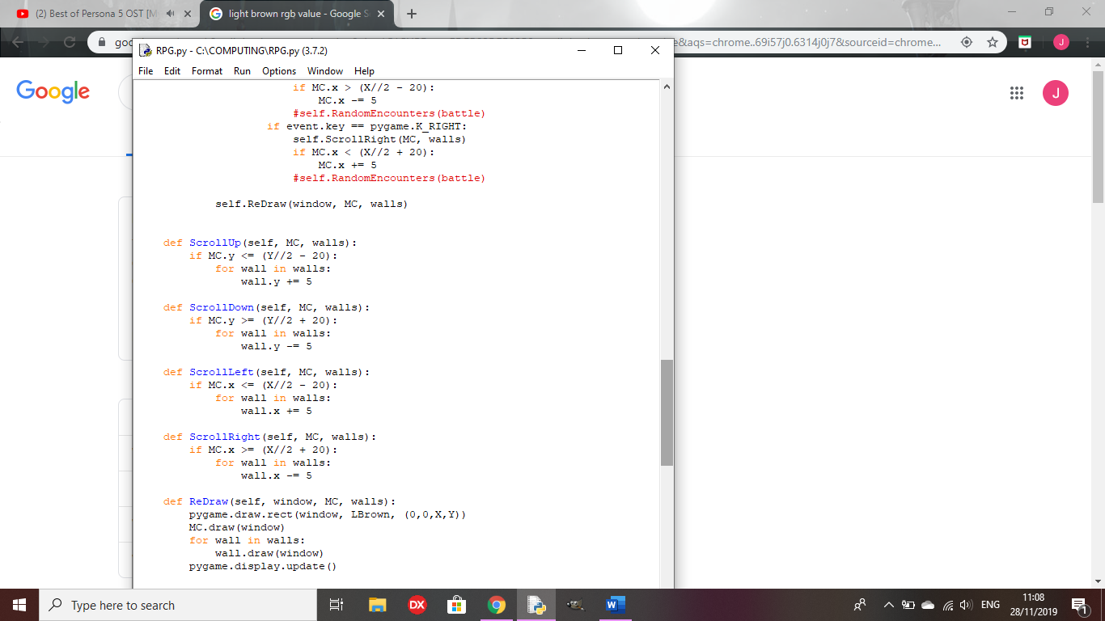

I have separate methods to scroll the objects if the main character is at a certain point on the screen, so they don’t just go offscreen if they get too far, and the objects that were offscreen will be pulled onscreen if the player is going in that direction.

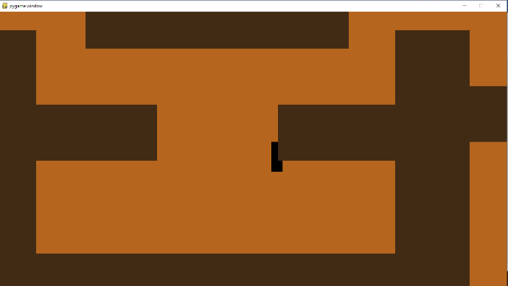There is no collision on the walls yet, so I will make a collision method that will check the position of the walls against the player every time they make a movement.

**Review Point 2**

The collision on the walls somewhat works but, if you hit the side of the wall, it sends you straight to the top. (See test 8). Random encounters are triggered as you move around the world, but battles are not yet implemented. It only says ‘Show time’ then ends.

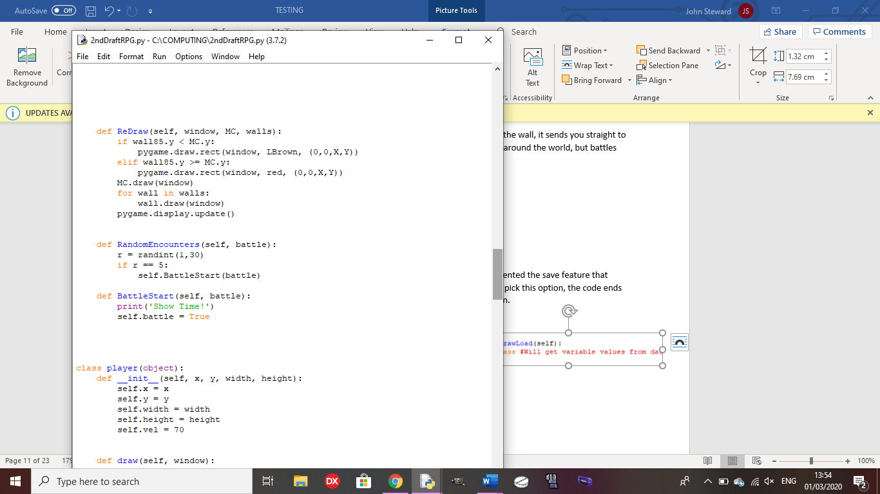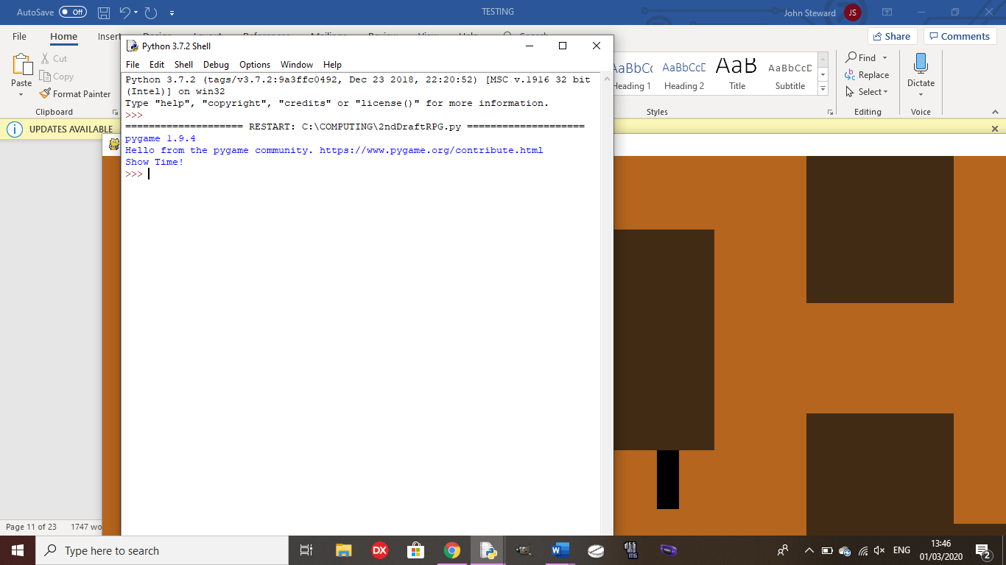

The ‘Continue Game’ option does not work yet as I have not implemented the save feature that would allow the player to start back from their save point yet. If you pick this option, the code ends as there is only a placeholder method for the ‘Continue Game’ option.

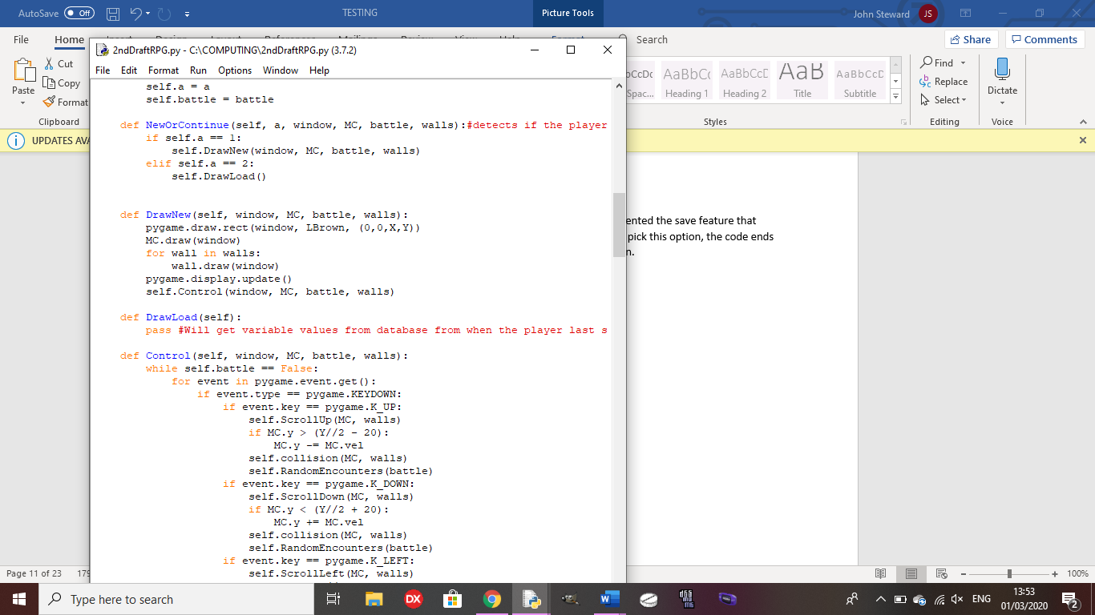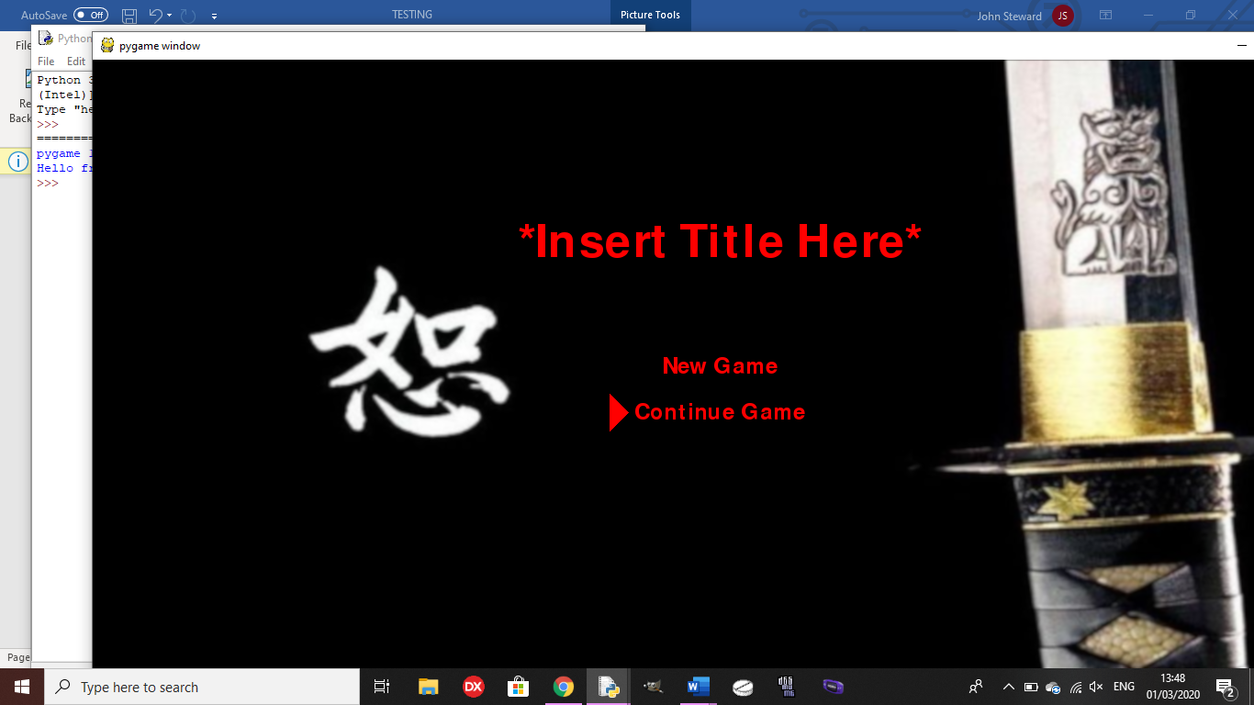

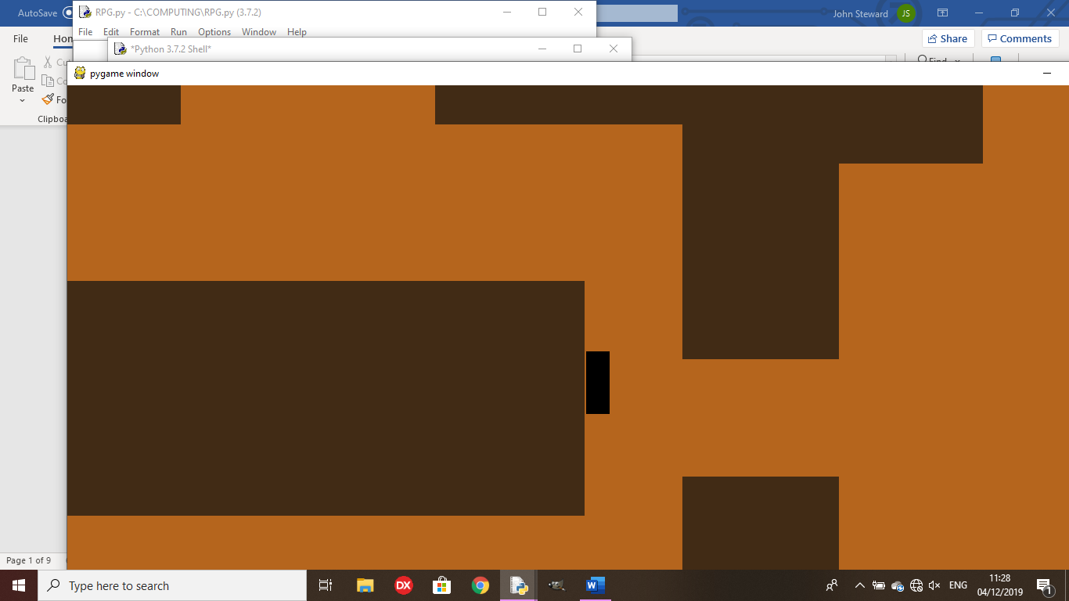Test 8: Does the collision block you from moving into the walls as intended?

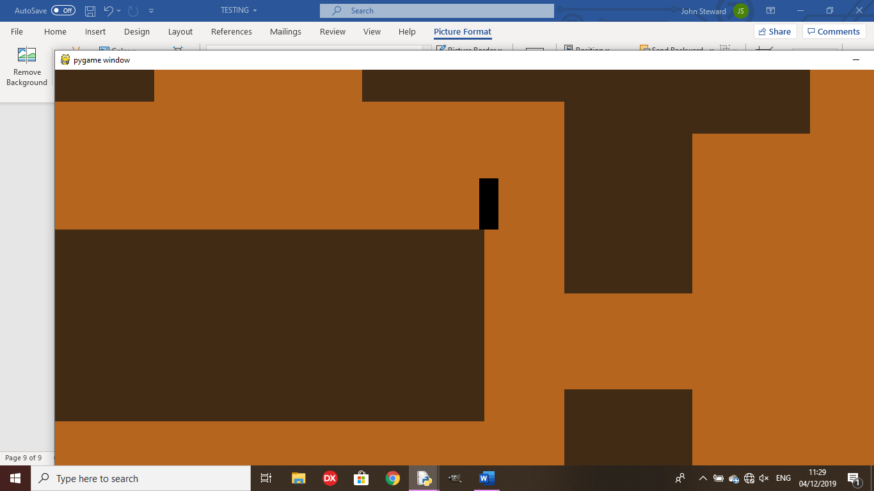Outcome: At the moment, the collision does not work quite as intended as, if you hit the sides of the wall, you will be placed right at the top, rather than stopping at the side.

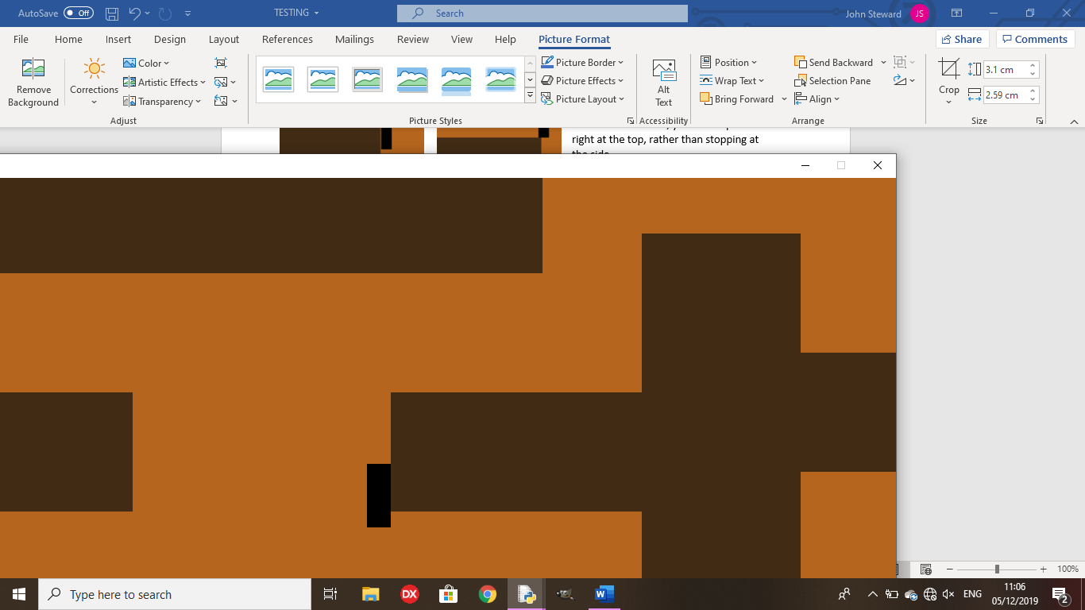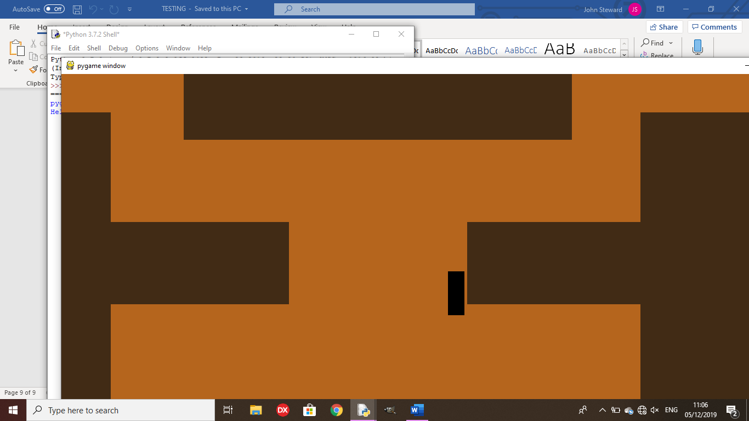 Remedy:

The character now colllides with the wall as intended, so it doesn’t jump to the top of the wall when hitting the side of it.

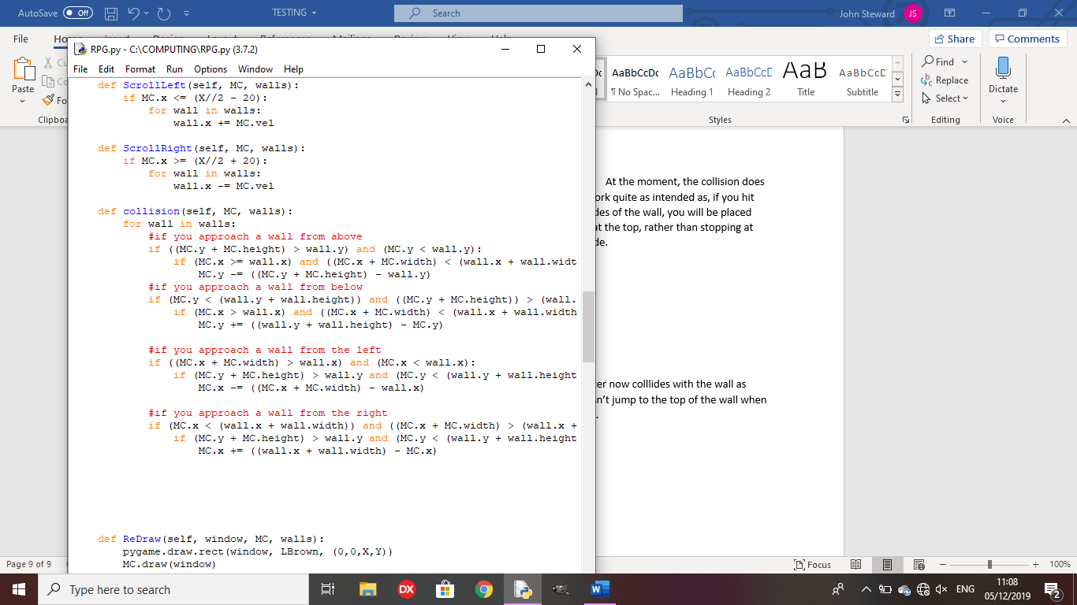

Test 9: Is the battle screen drawn and does it allow for player input?

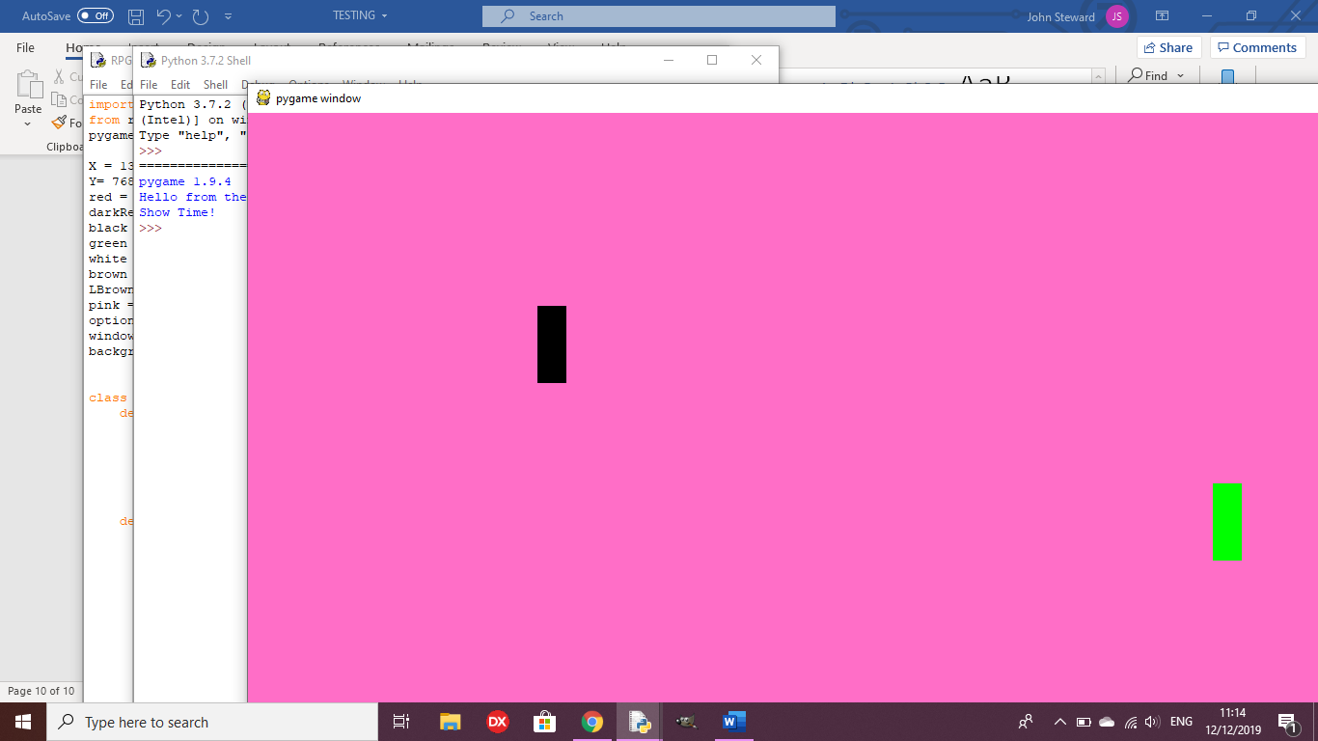

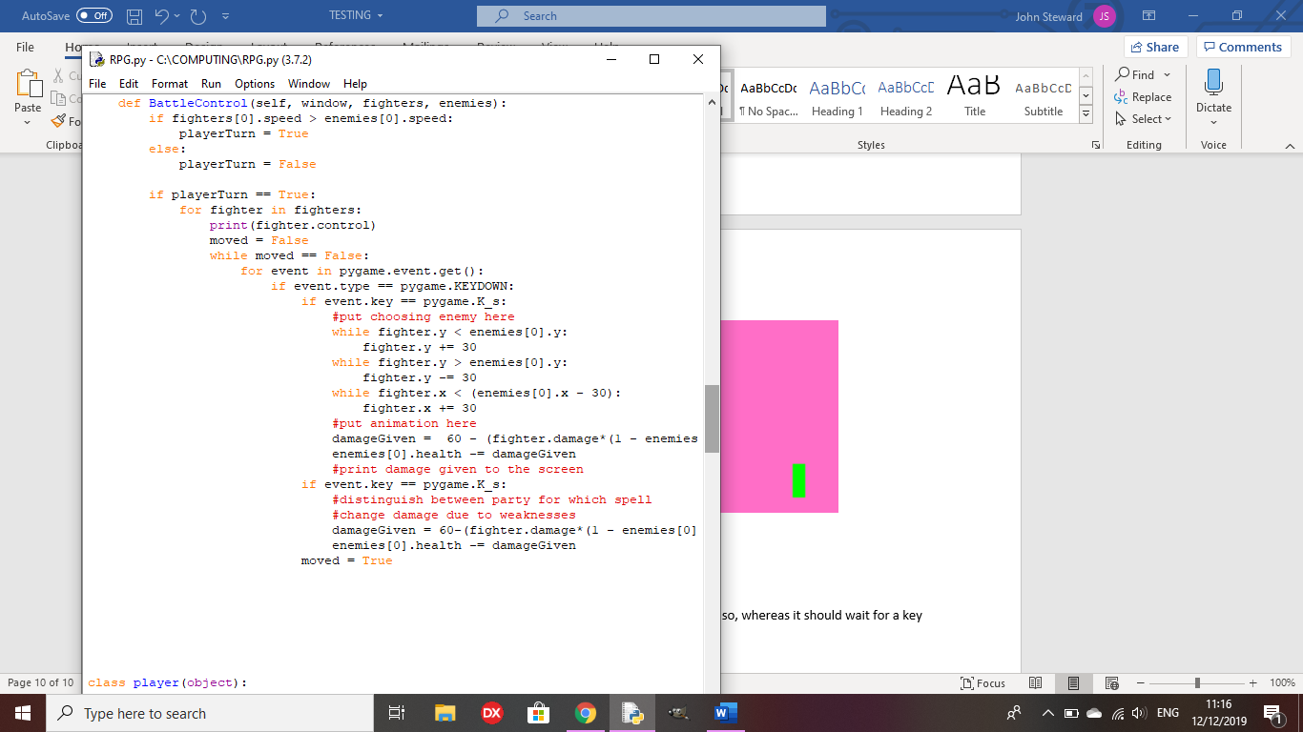

Outcome:

The battle screen is drawn, but the code ends as soon as it does so, whereas it should wait for a key input from the player.

Remedy:

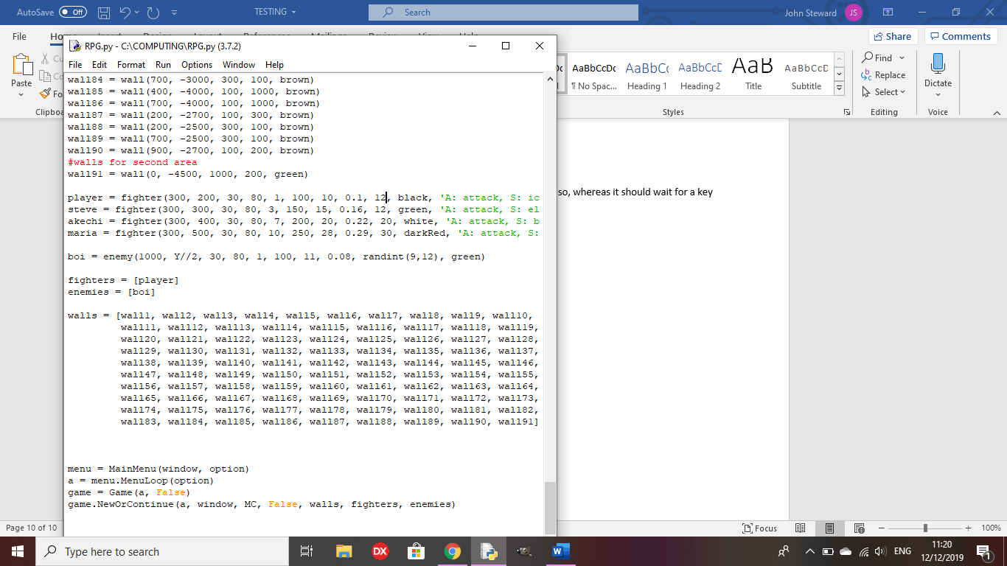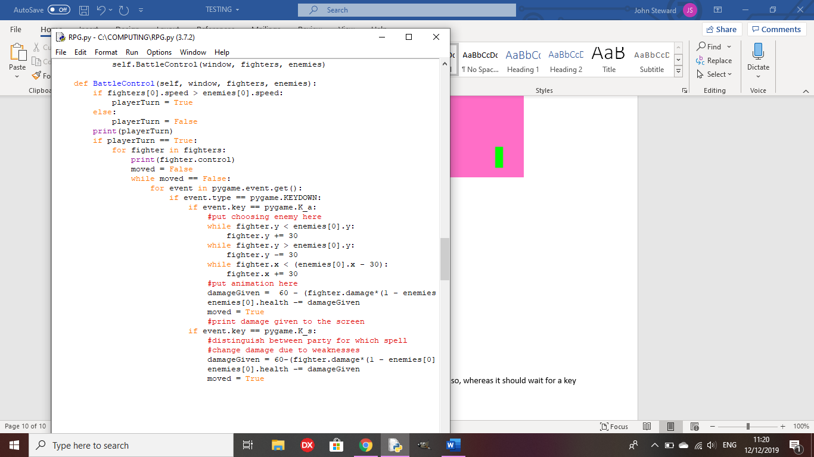I had to alter the speed stat of my character to be higher than the enemy’s, because I haven’t coded the enemy turn yet, so now it waits for the player’s input.

Test 10: Does the battle end and return to the overworld?

Outcome:

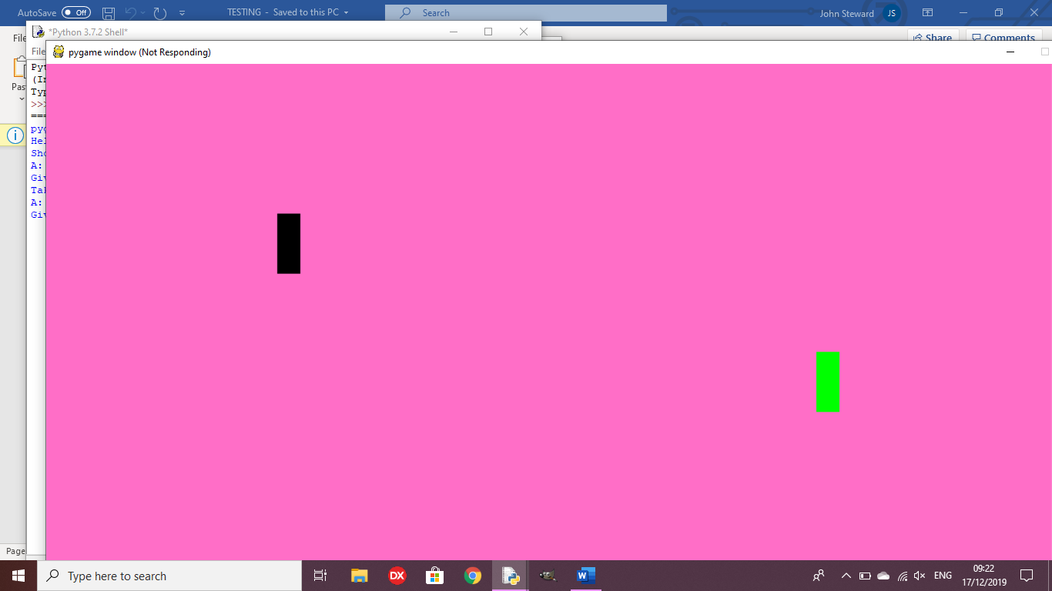The game crashes after all of the enemies on screen have been killed.

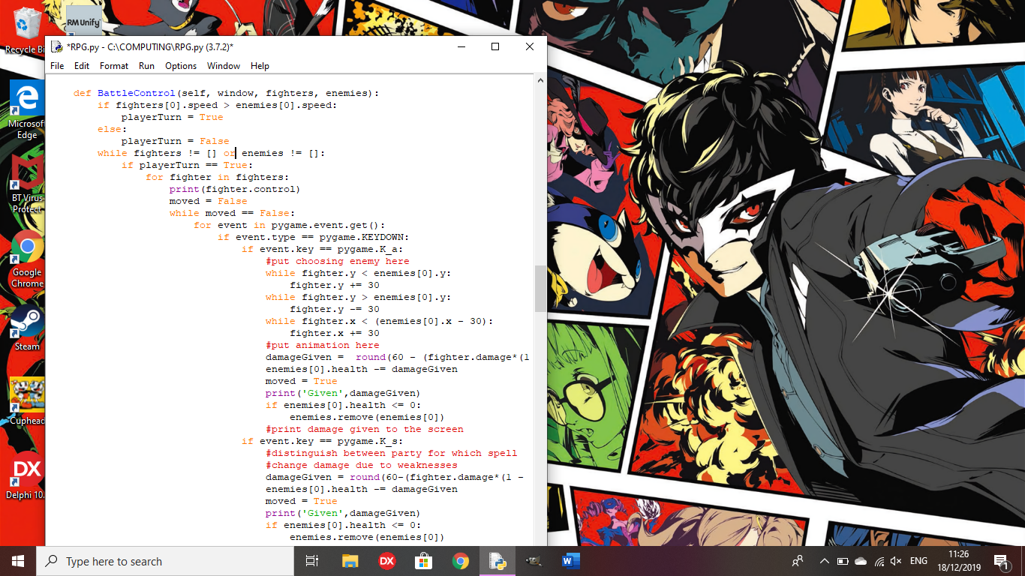This is because it was put into an infinite loop since there were no enemies to kill the remaining fighters.

Remedy:

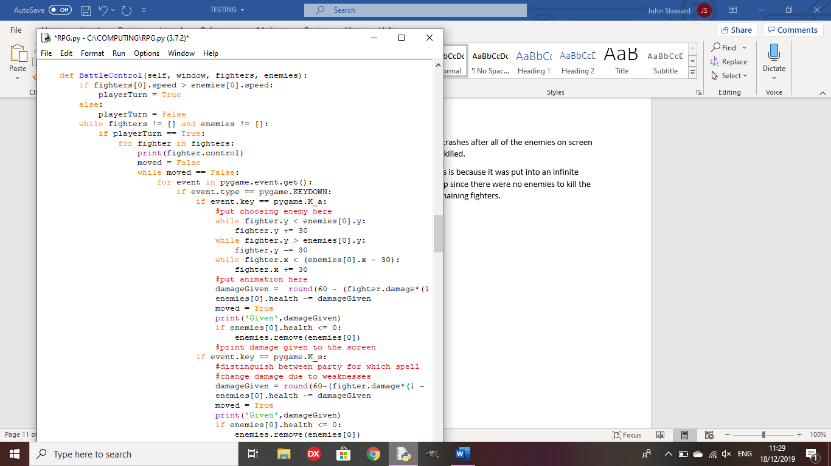The battle now ends once all the elements of either list have been removed, eliminating the infinite loop

Test 12: When there are multiple enemies, can the player choose who to attack?

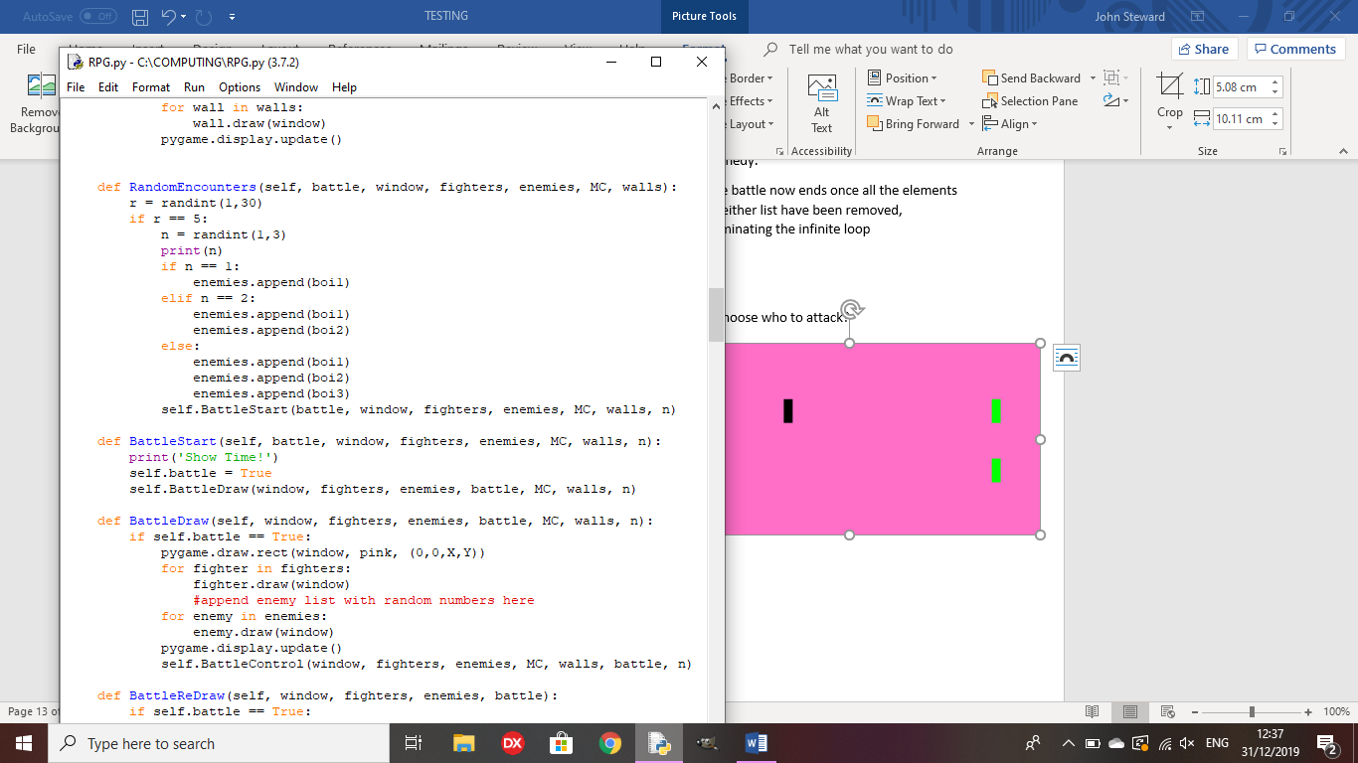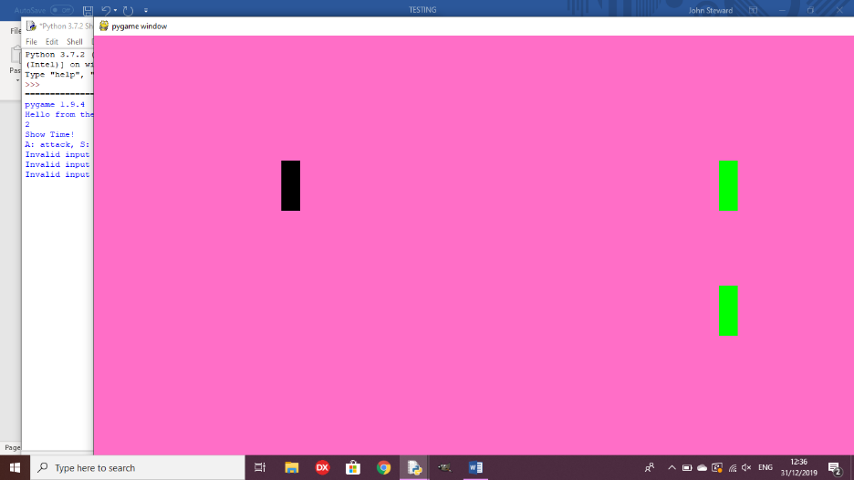

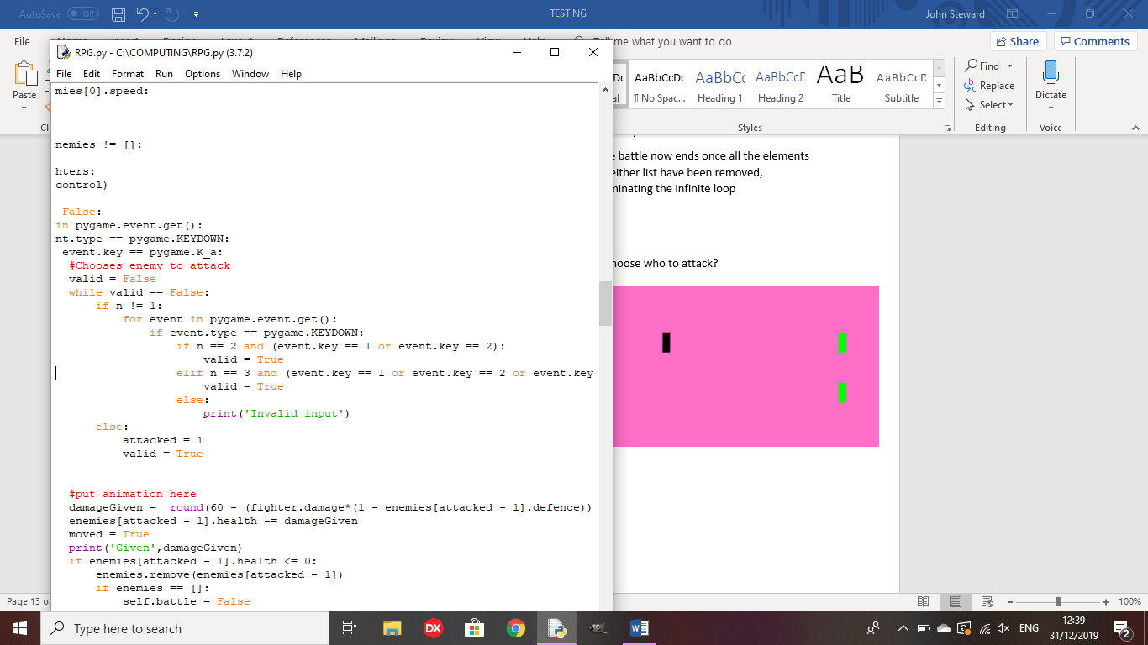

Outcome: All inputs are ‘invalid inputs’, so you cannot attack any enemies

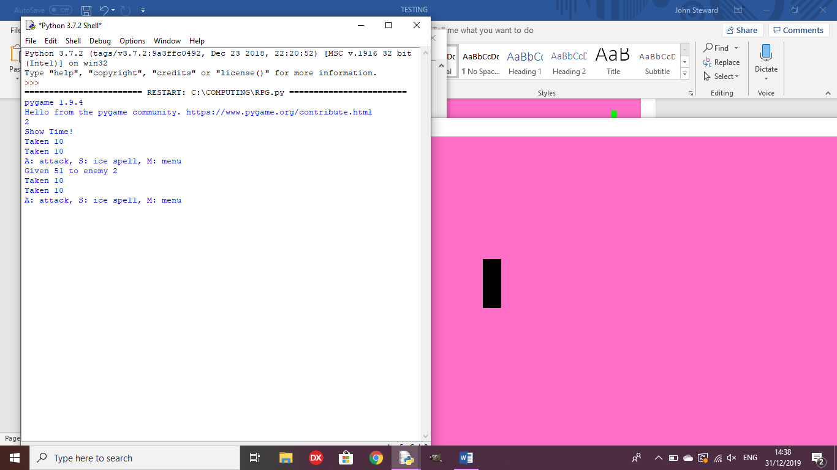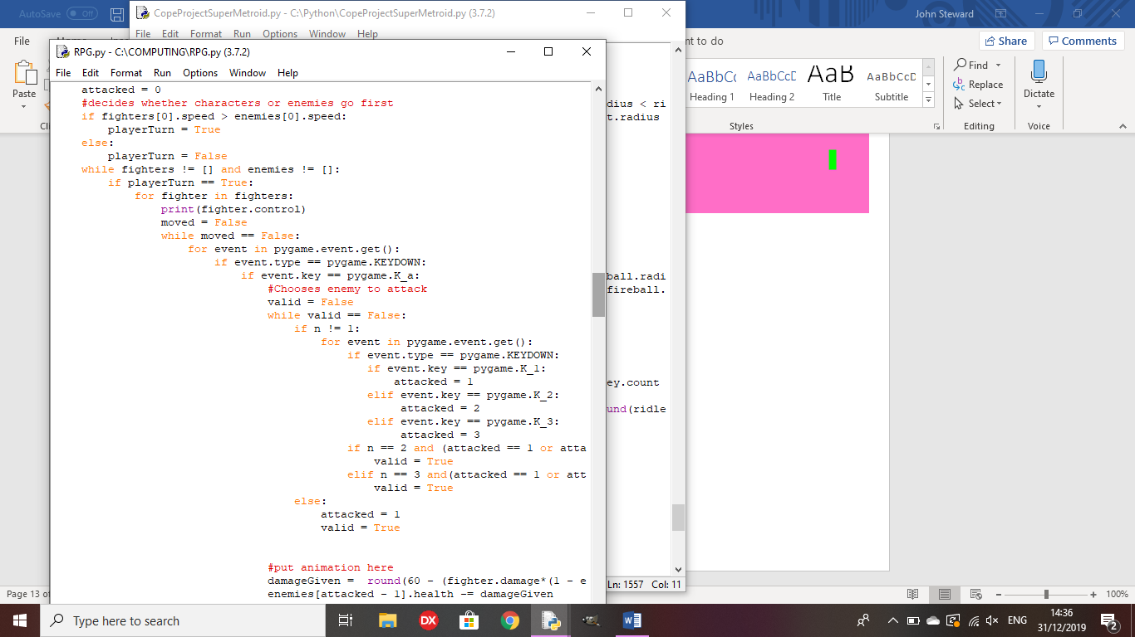Remedy:

I gave ‘attacked’ a value based on the input, which determines the enemy that is attacked by the player

Test 13: does the player gain EXP upon killing enemies?

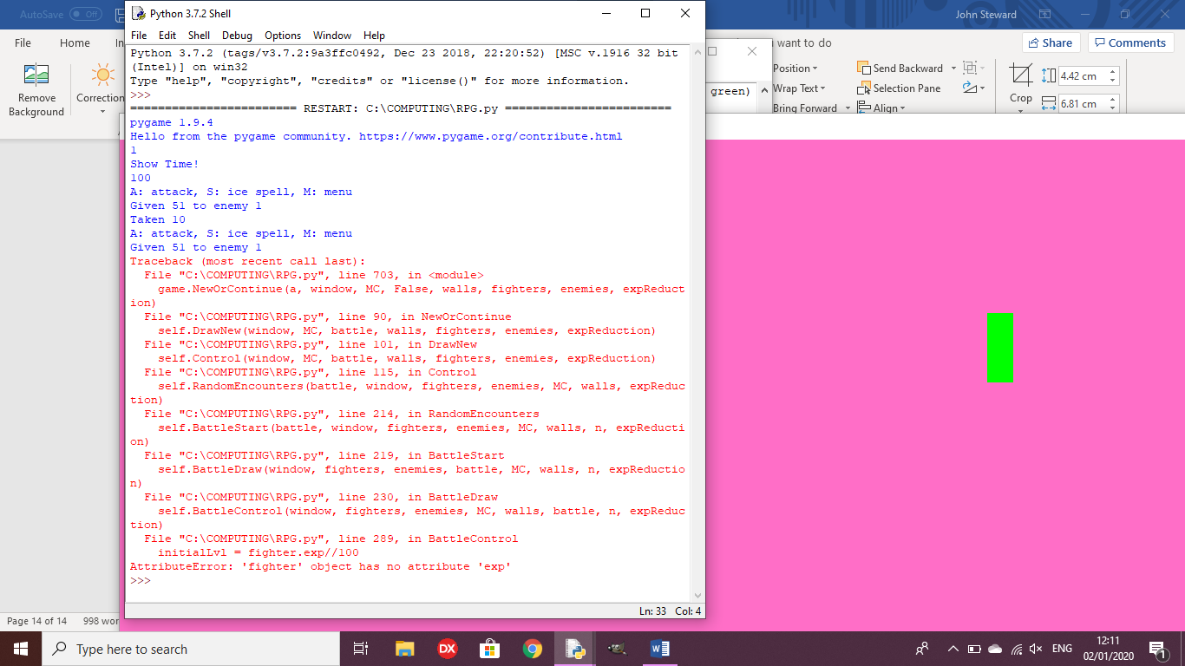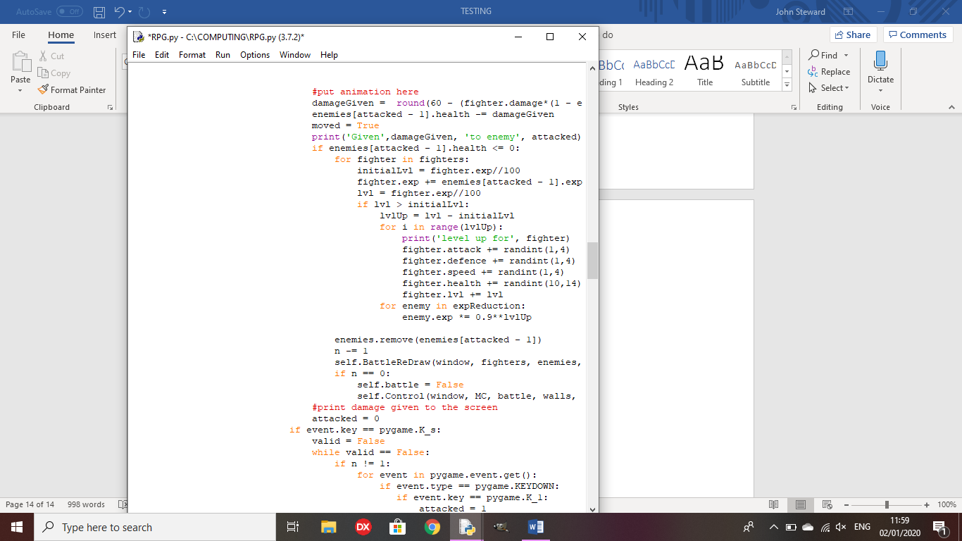

Outcome: The fighter does not have an EXP value

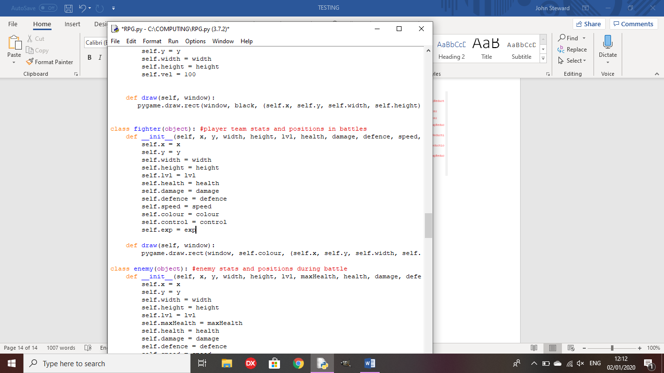Remedy: exp is added to the initialisation method for fighter

Test 14: Does the player level up upon receiving enough EXP?

Outcome: The player levels up upon receiving 100 EXP and the exp gain from enemies reduces upon each level gain.

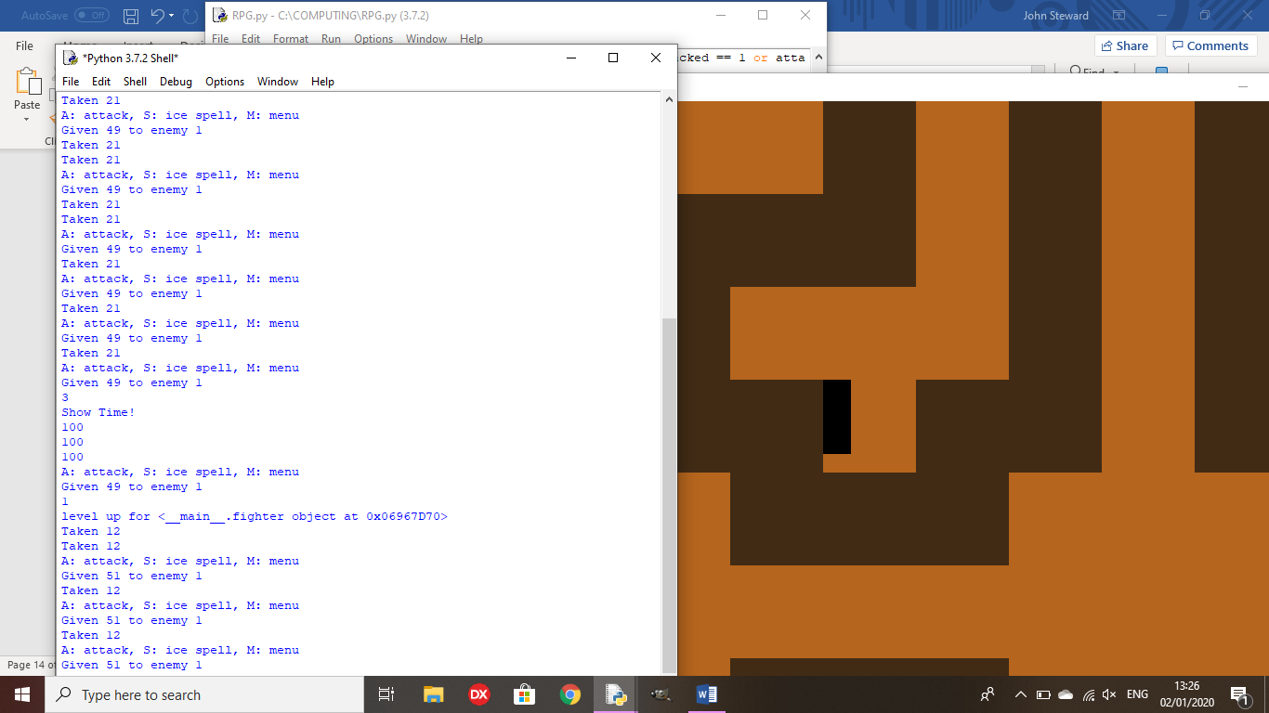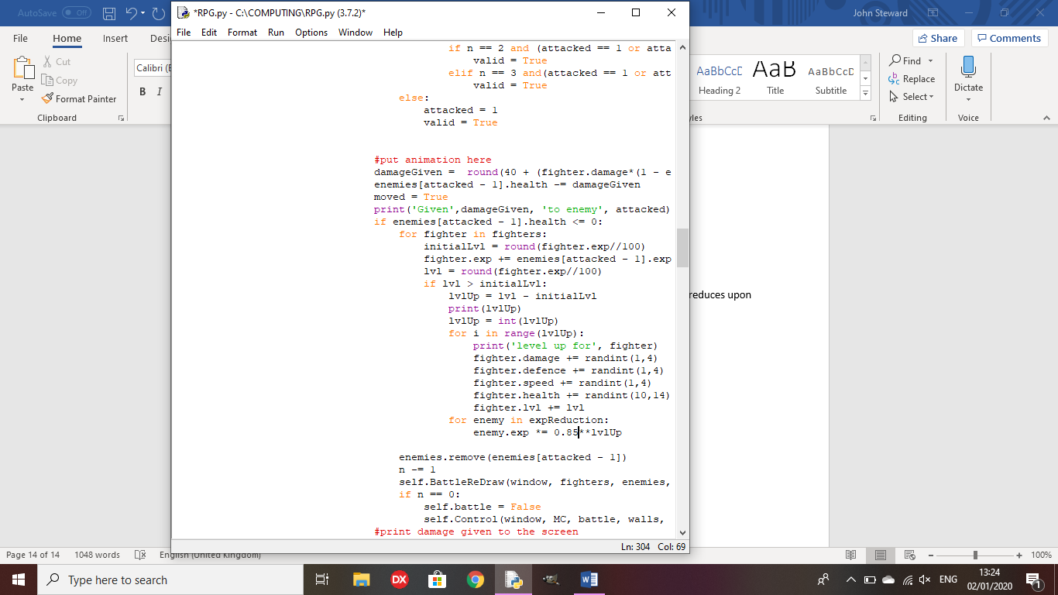

**Review Point 3**

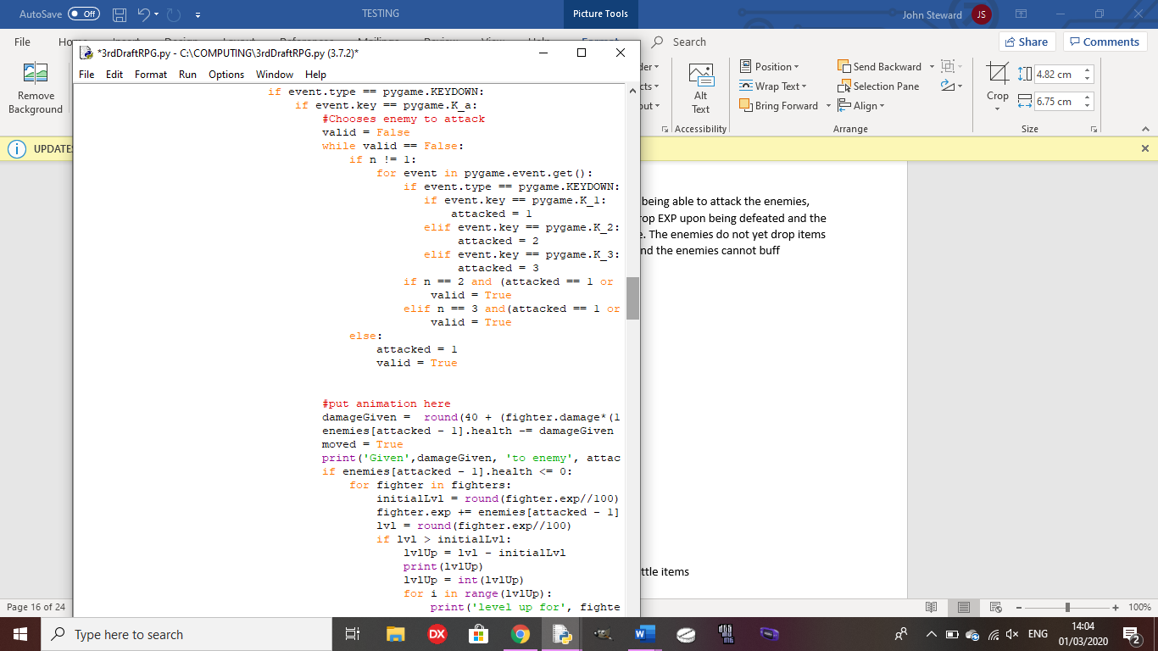Random encounters cause battles to take place, with the player being able to attack the enemies, and the enemies being able to attack the player. The enemies drop EXP upon being defeated and the player characters will level up once they gain enough experience. The enemies do not yet drop items when defeated, the player cannot yet use items during battles and the enemies cannot buff themselves yet.

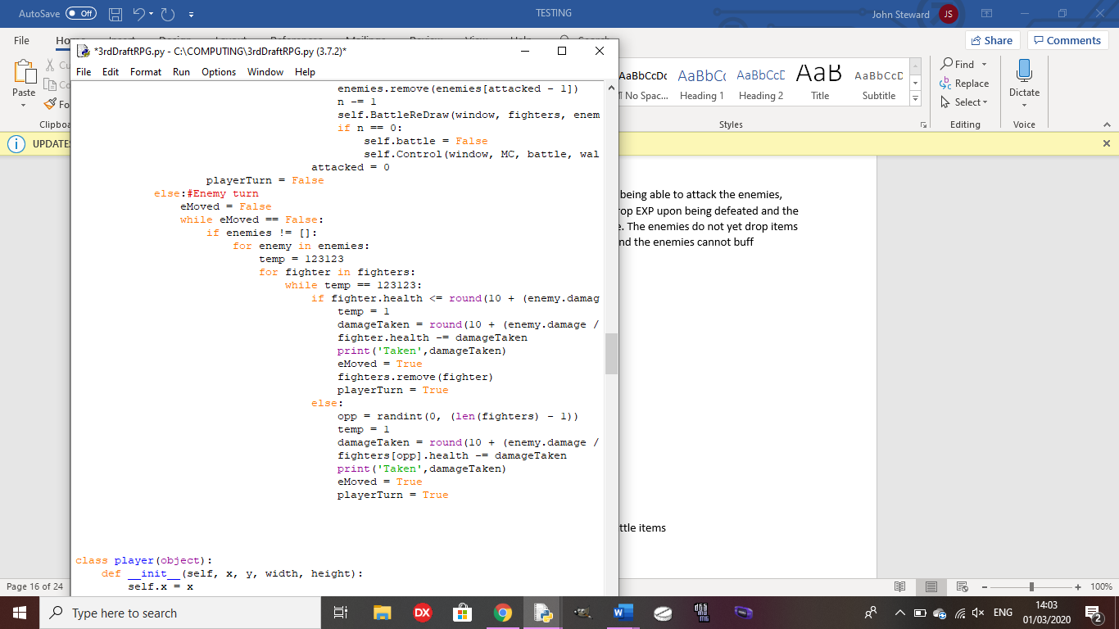

The sprite for the first boss is drawn to the screen, but you cannot yet encounter him as the function to encounter a boss has not yet been made.

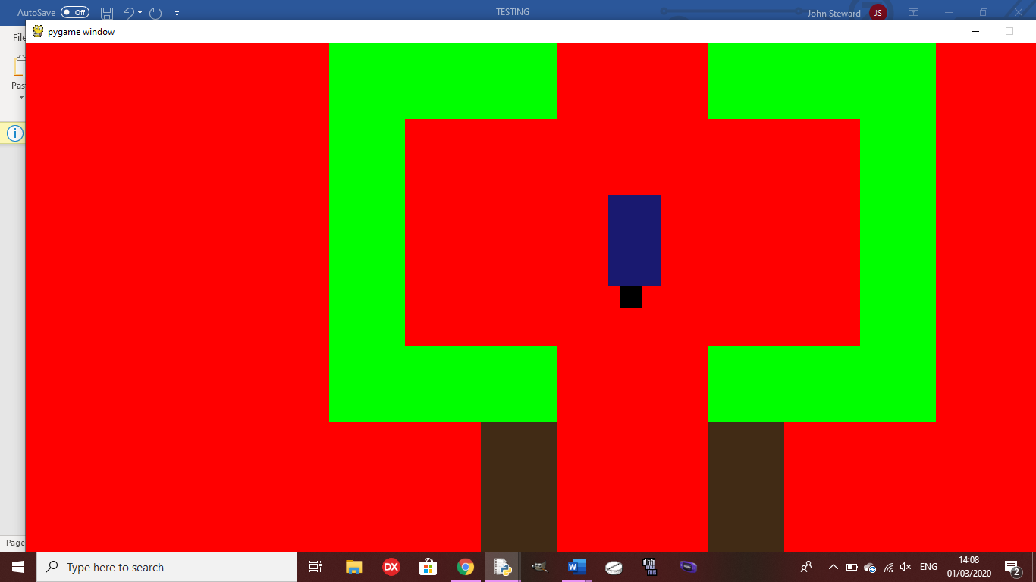

Test 15: Do enemies drop battle items upon defeat?

Outcome: Upon ending the battle, each enemy drop one of 3 battle items

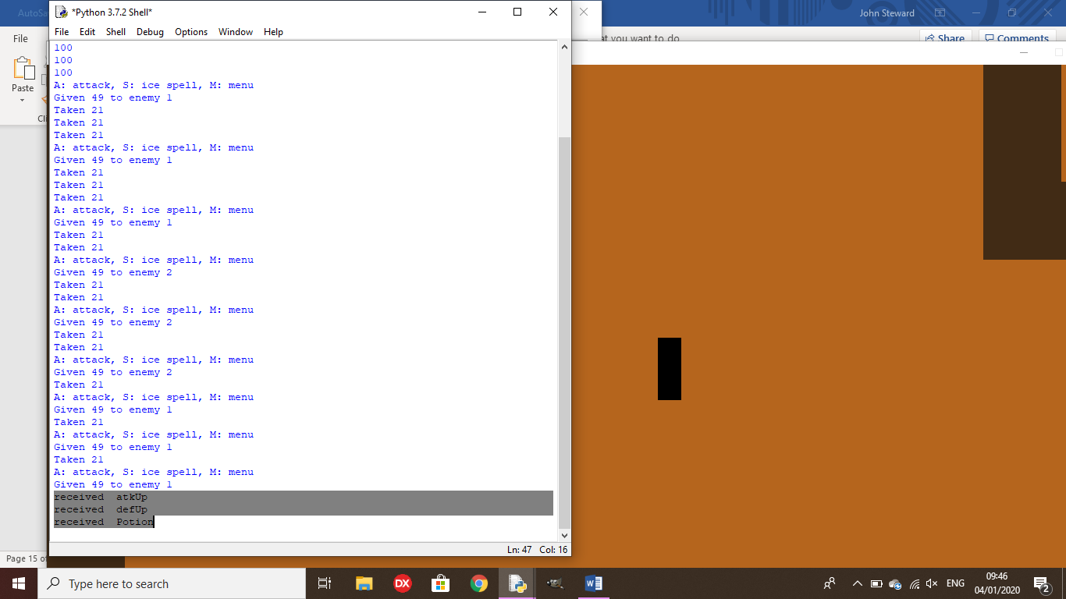

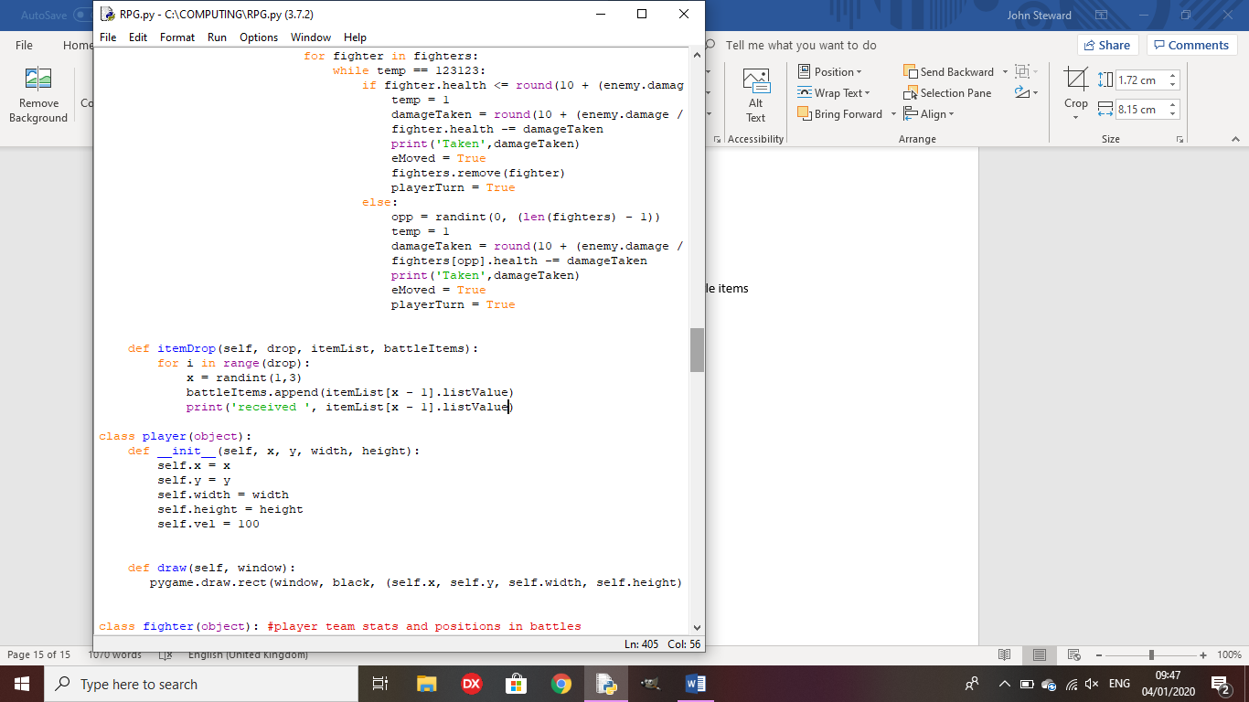

Test 16: Do items work in battle?

Outcome: In this example, a defUp is used in battle, permanently increasing the character’s defence stat.

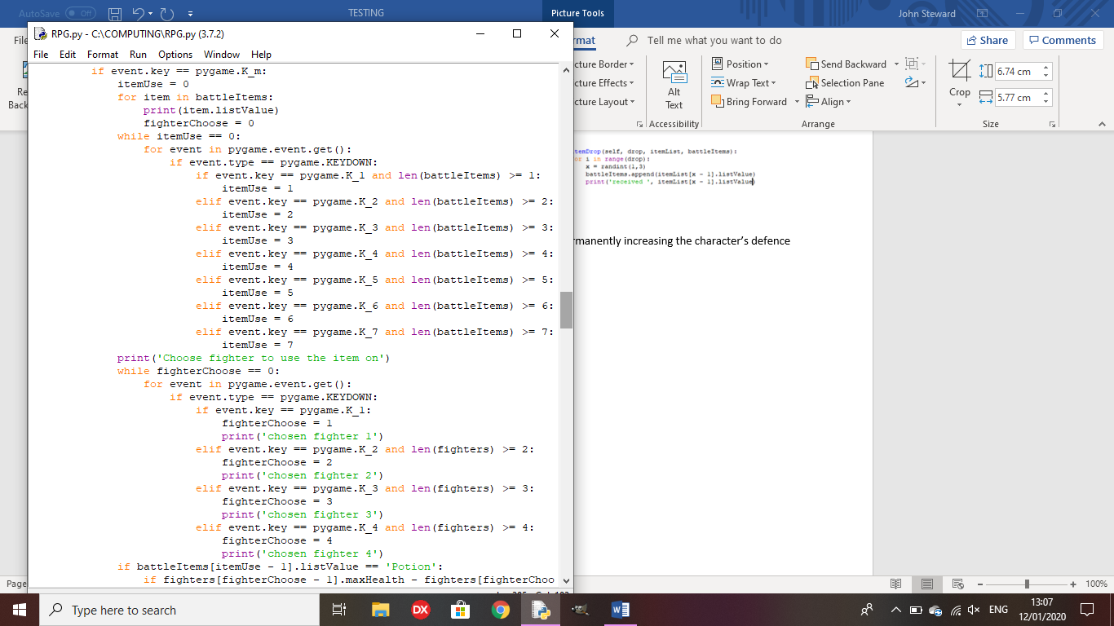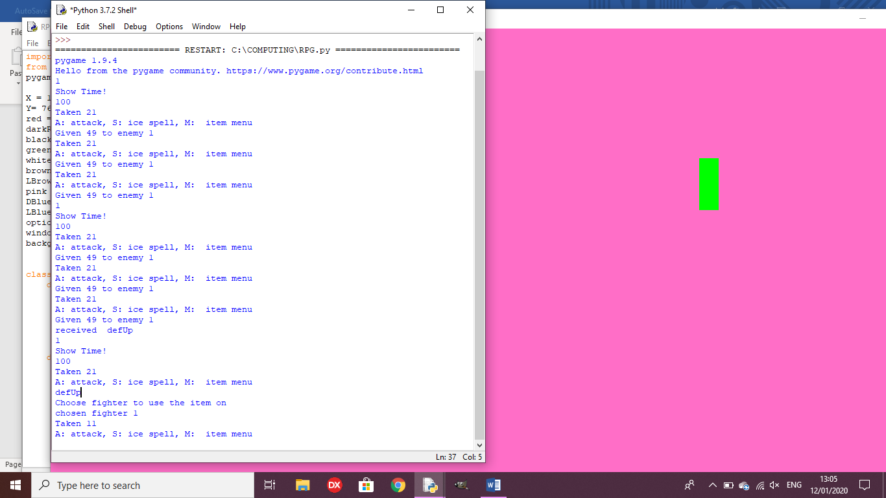

Test 17: Does the boss fight begin when the dialogue has been shown for the boss?

Outcome: When the player presses space after the dialogue is shown, the battle scene is drawn.

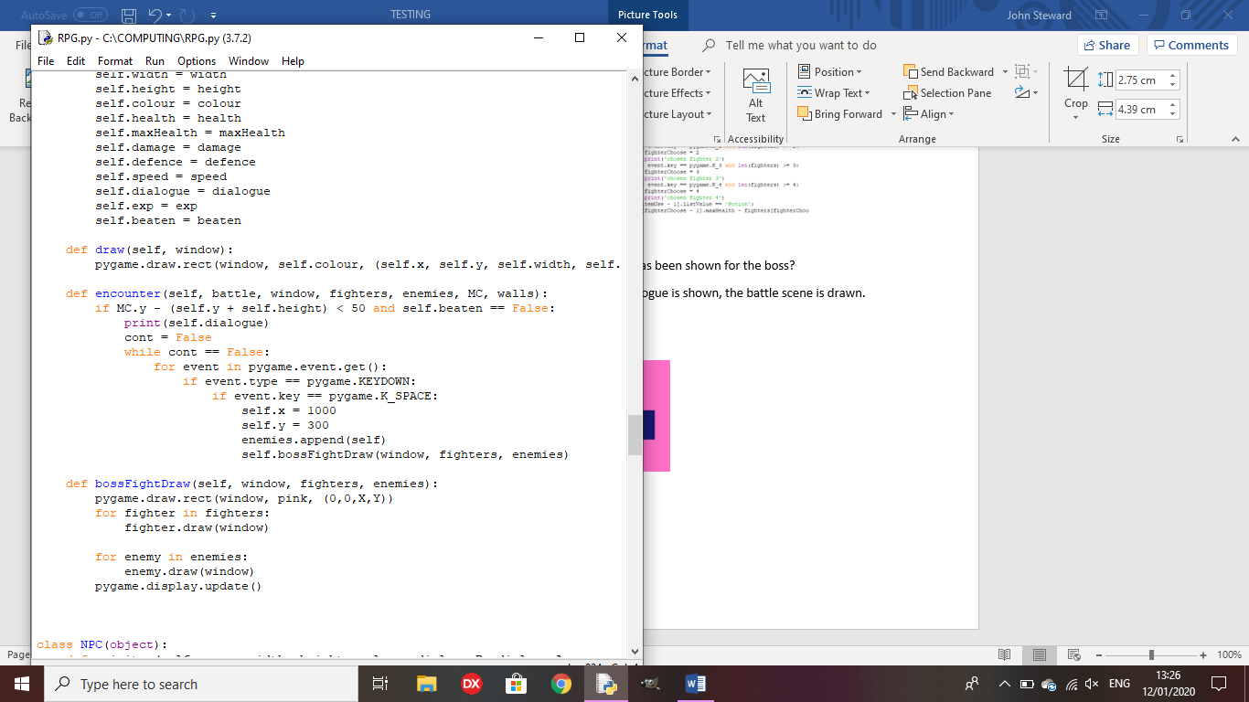

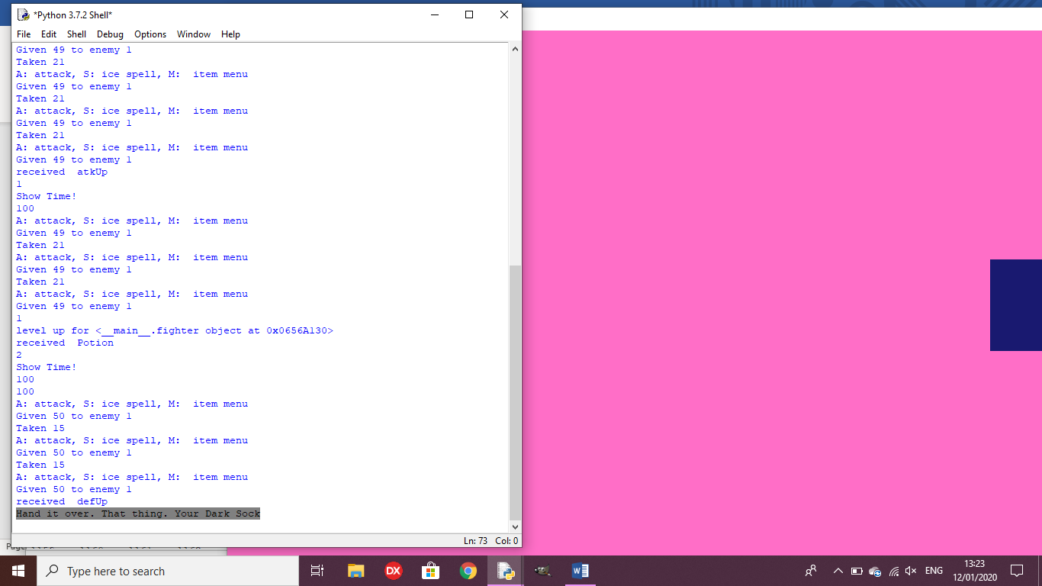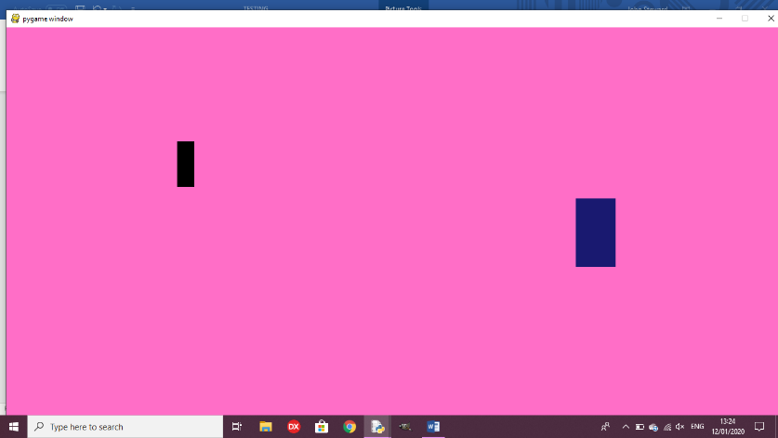

Test 18: Does the boss fight control work?

Outcome: I forgot to call the method, so you cannot attack the boss.

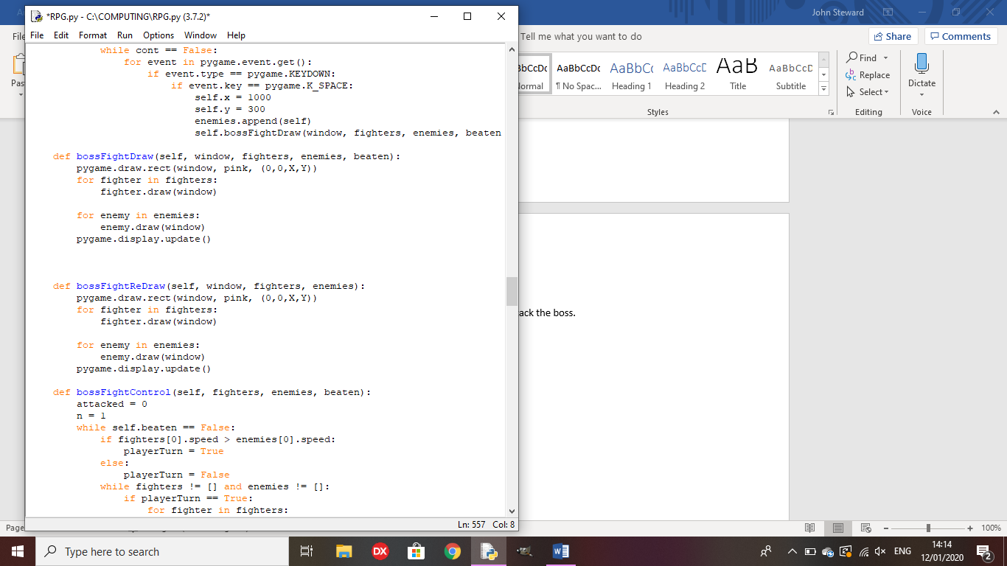

Remedy: I called the method in the bossFightDraw method so you will be able to attack the boss.

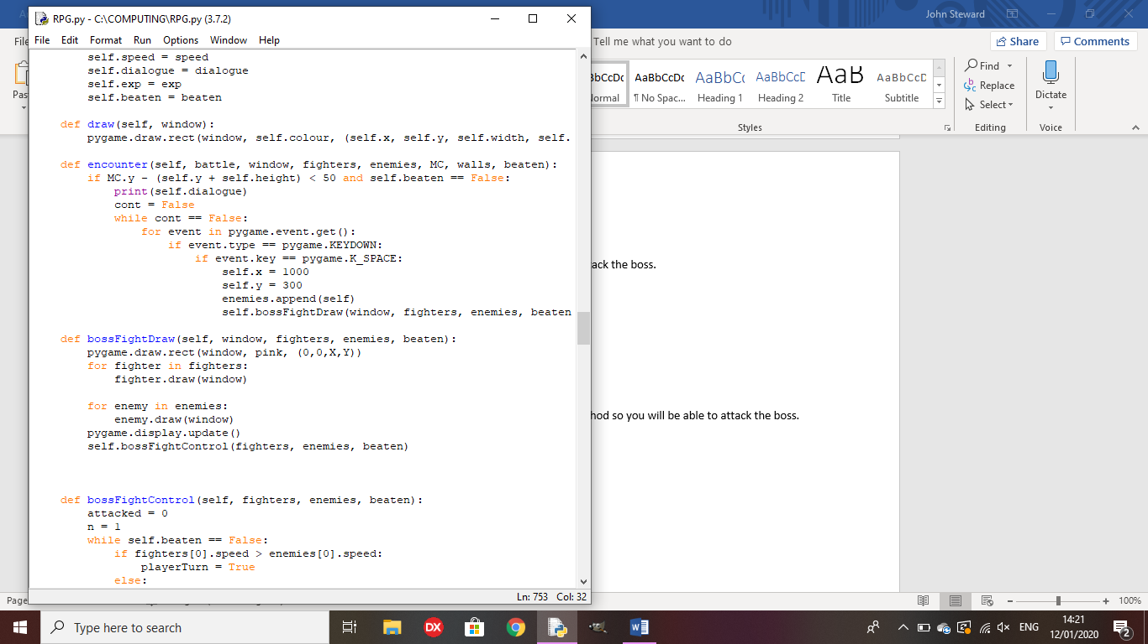

Test 19: When the boss is defeated, does gameplay continue in the overworld?

Outcome: The game acknowledges that the boss is defeated but does not return to the overworld.

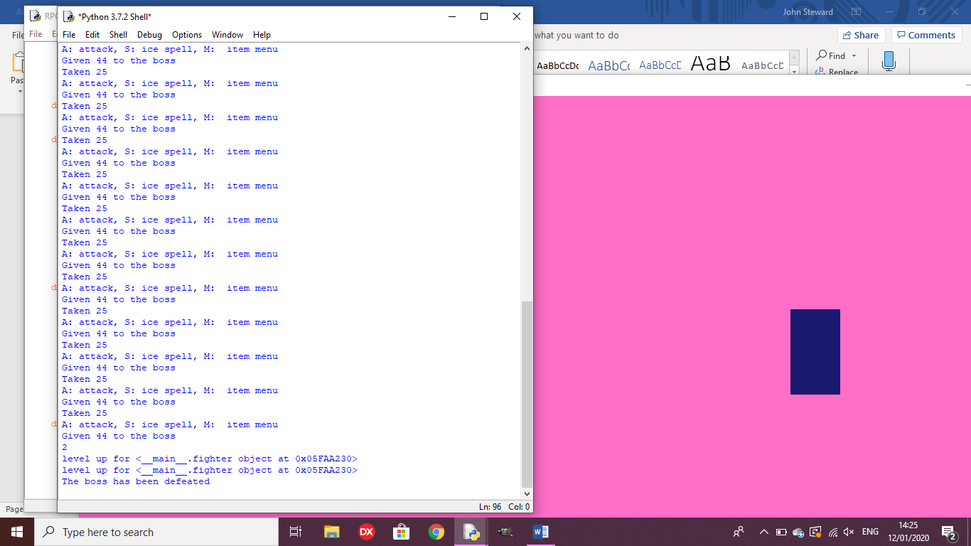

Remedy: I made the cont variable true after the fight, causing the fight to end and the game to carry on.

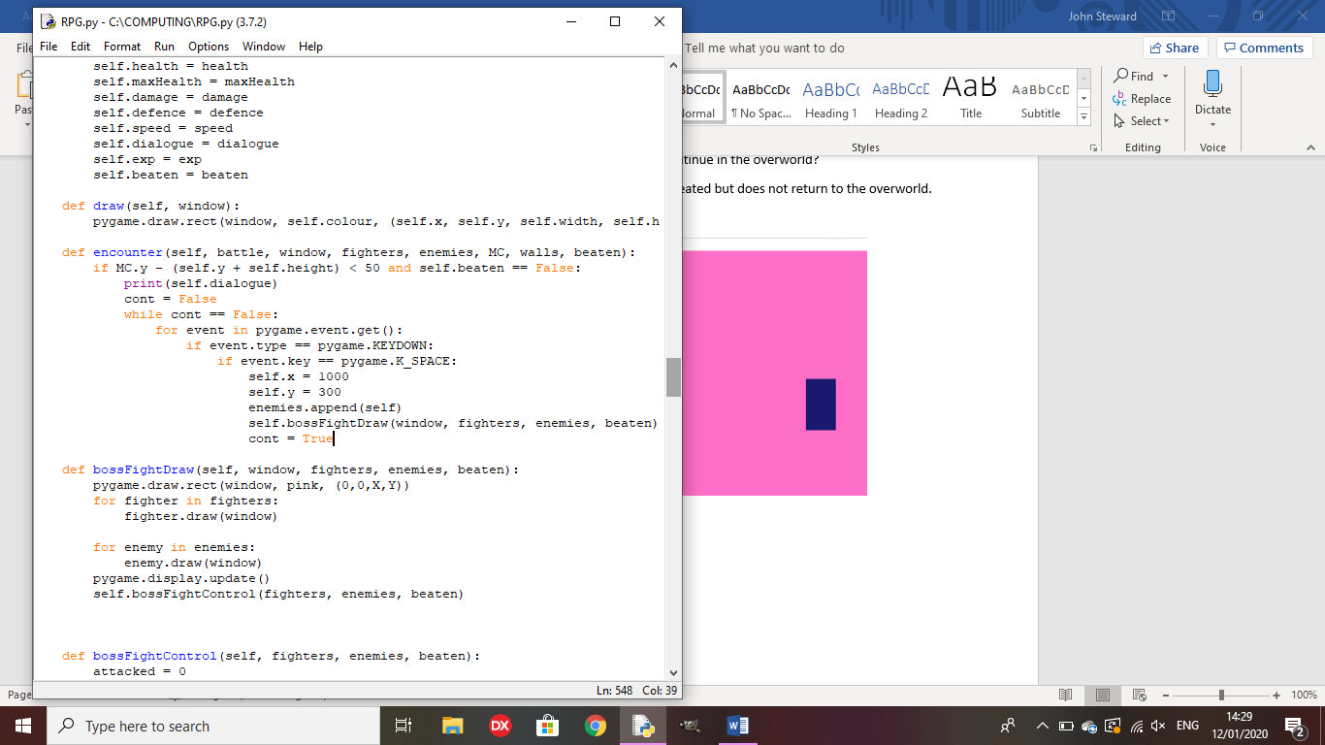

Test 20: Does the NPC speak its first dialogue line when interacted with?

Outcome: The interaction causes an error.

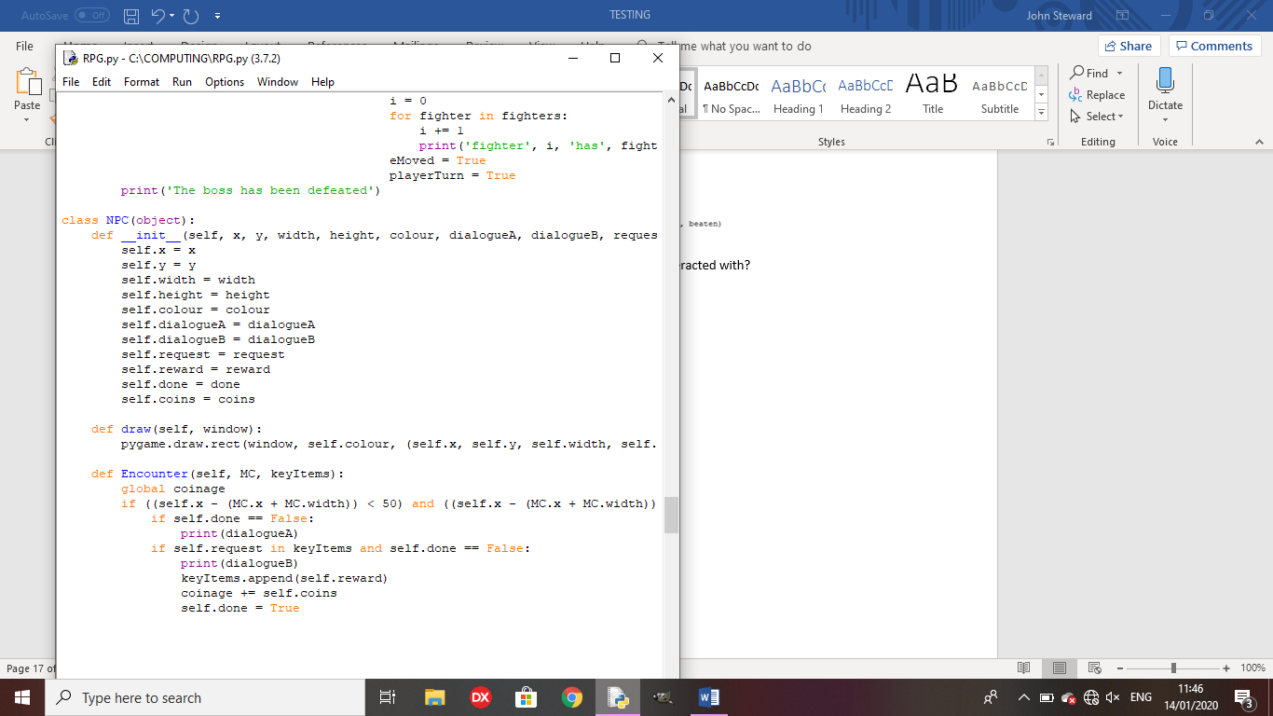

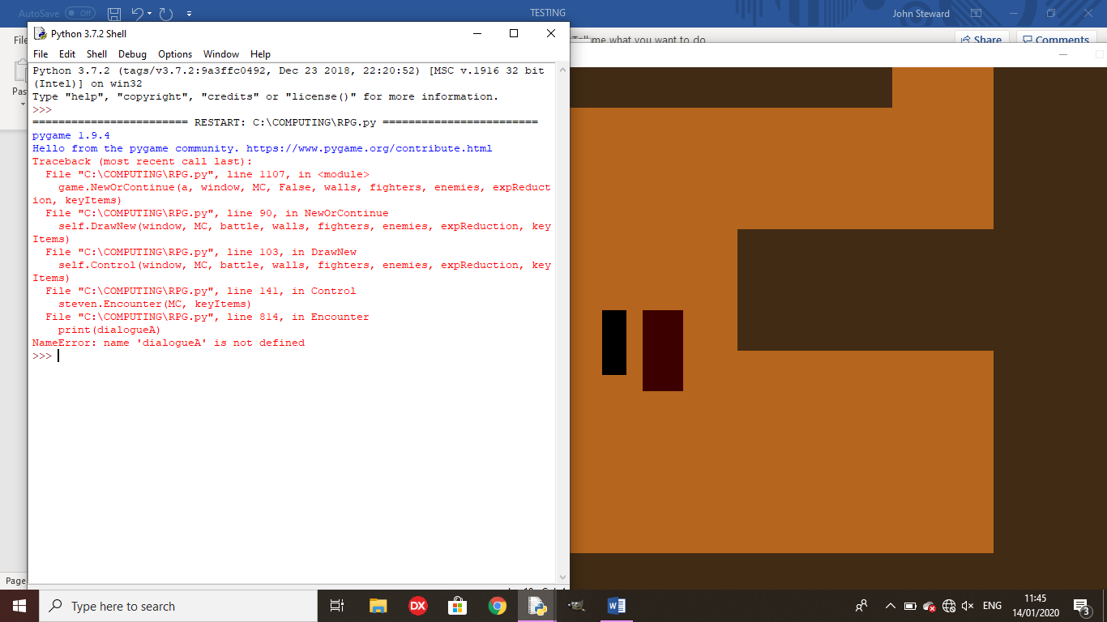

Remedy: I replaced ‘dialogueA’ and ‘dialogueB’ with ‘self.dialogueA’ and self.dialogueB’ respectively.

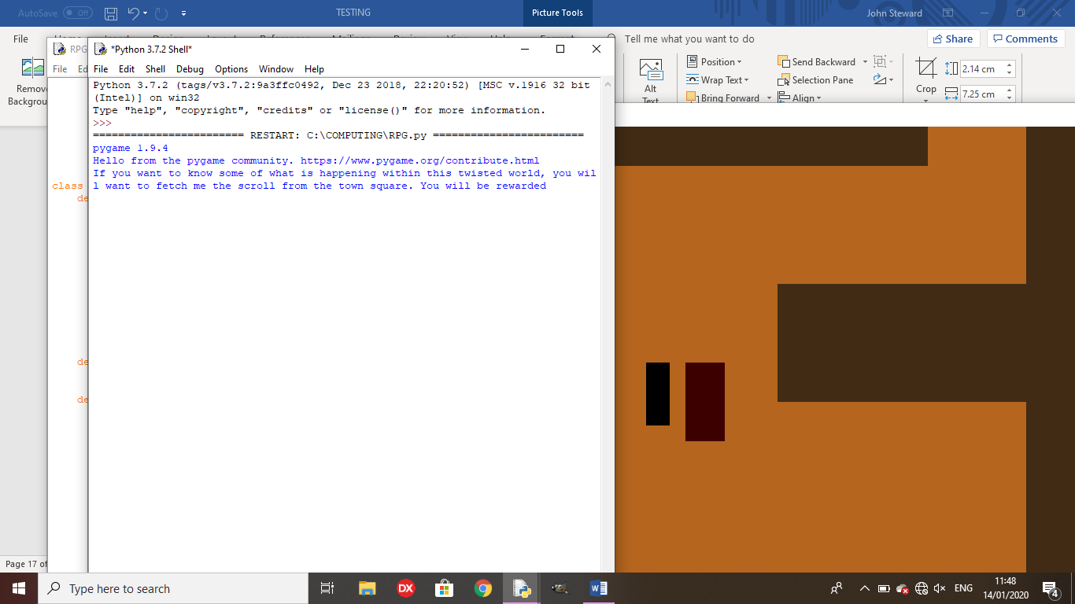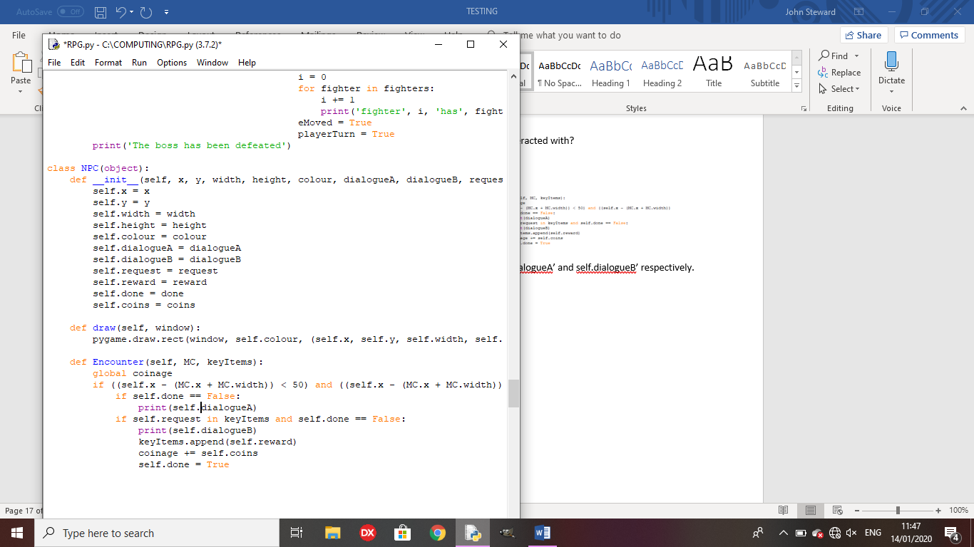

Test 21: Can the player pick up an overworld item and have it be placed in the keyItems list?

Outcome:

When the player is over the item and presses space, the item is picked up and placed in keyItems.

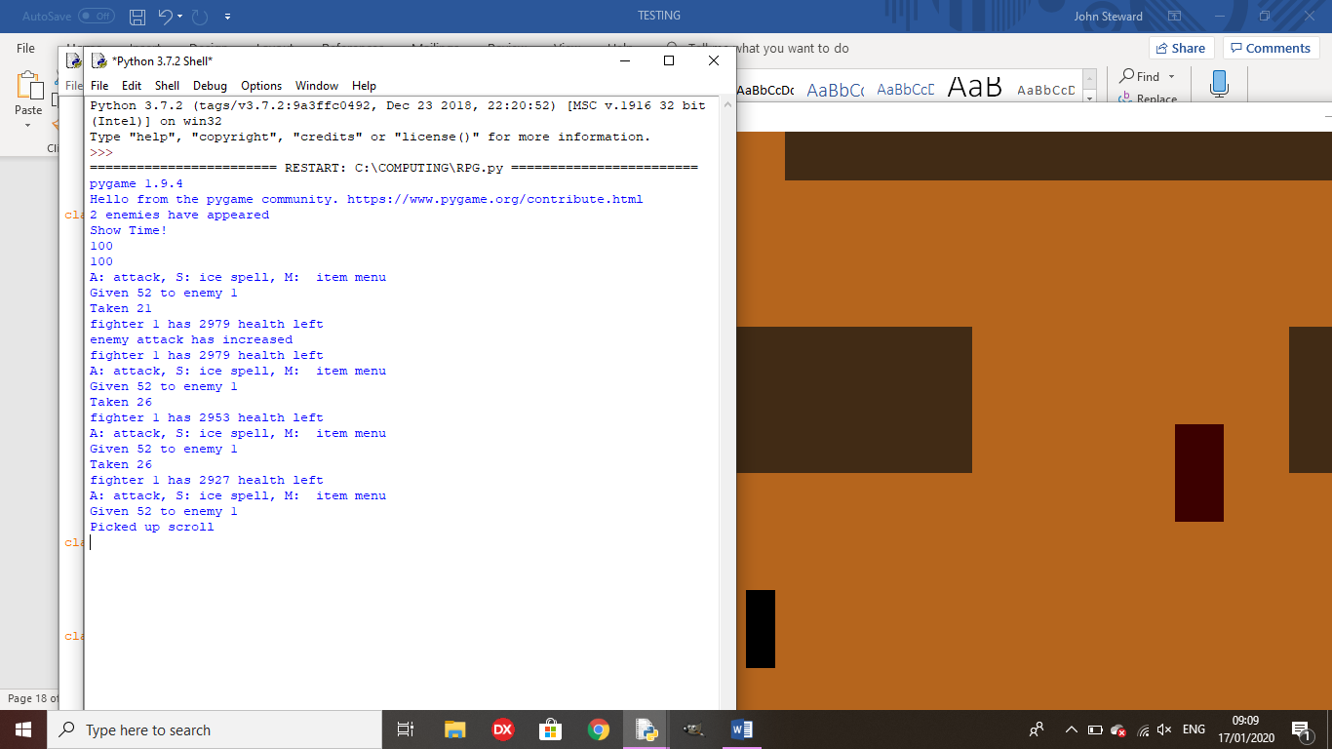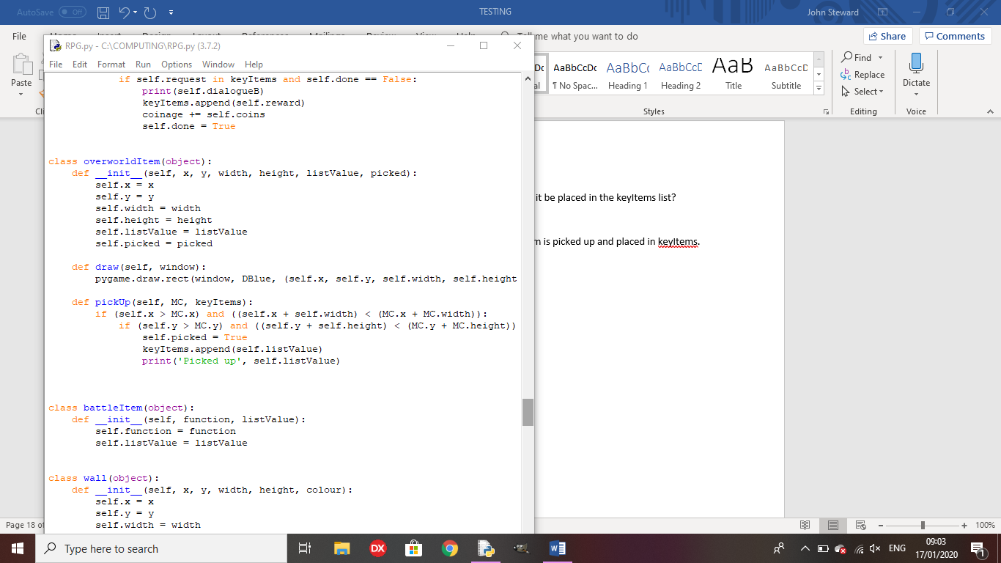

Test 22: Can the player finish the sidequest when they have the correct item in their inventory?

Outcome: The player can complete the sidequest but the rewards don’t work as I haven’t defined ‘Coinage’ before adding to it.

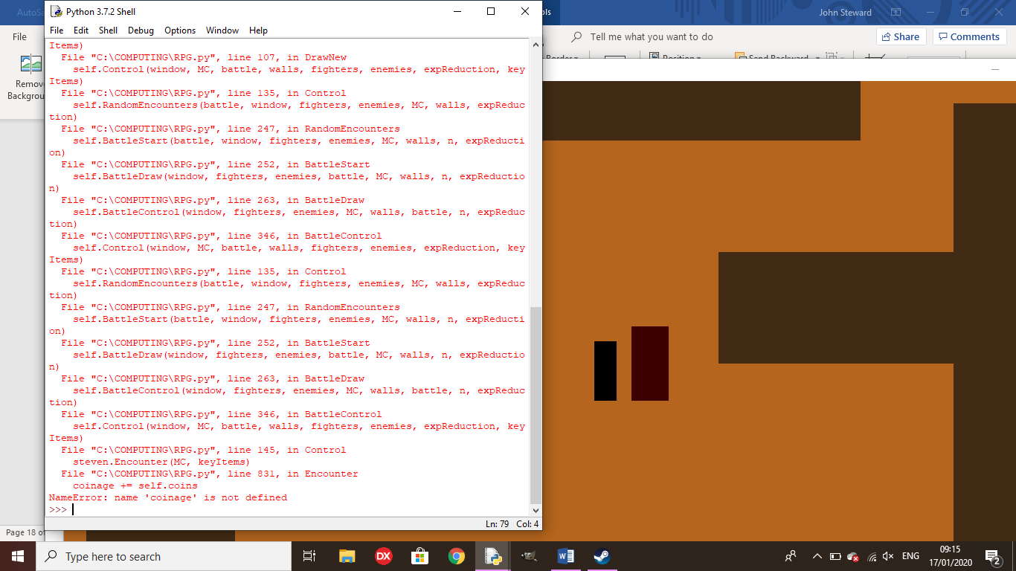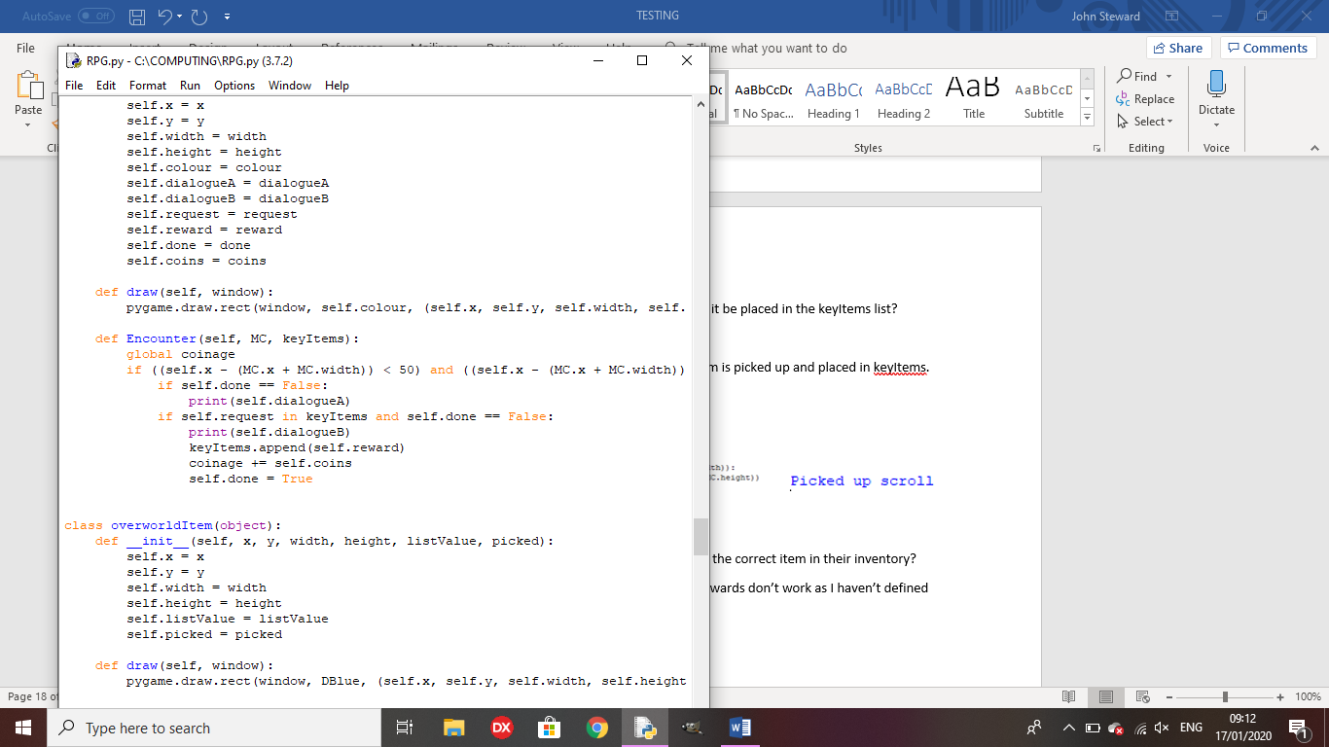

Remedy: I set ‘coinage’ to 0 at the top of the program.

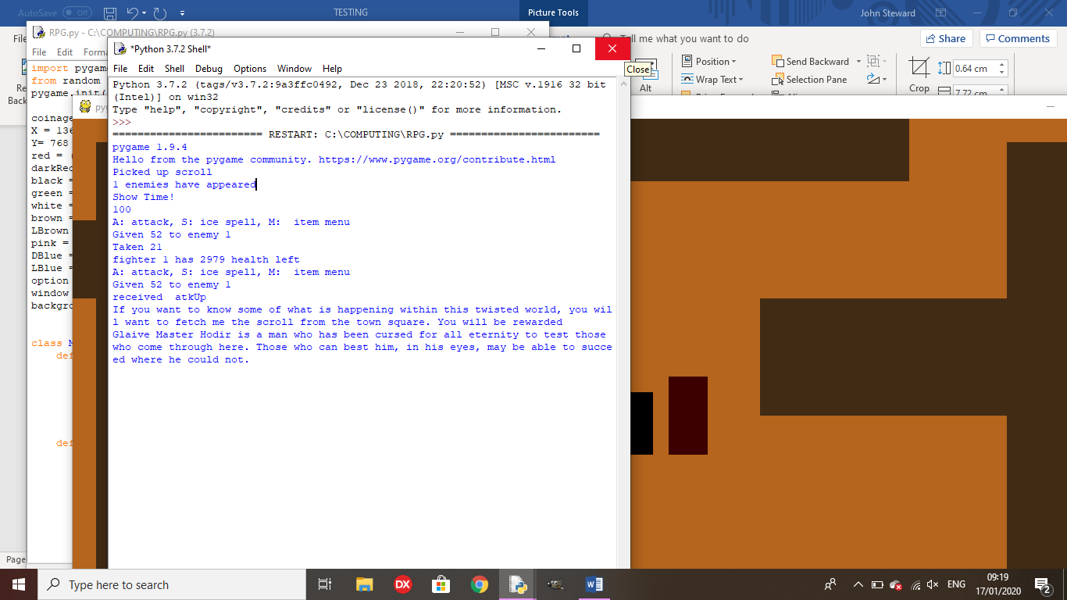

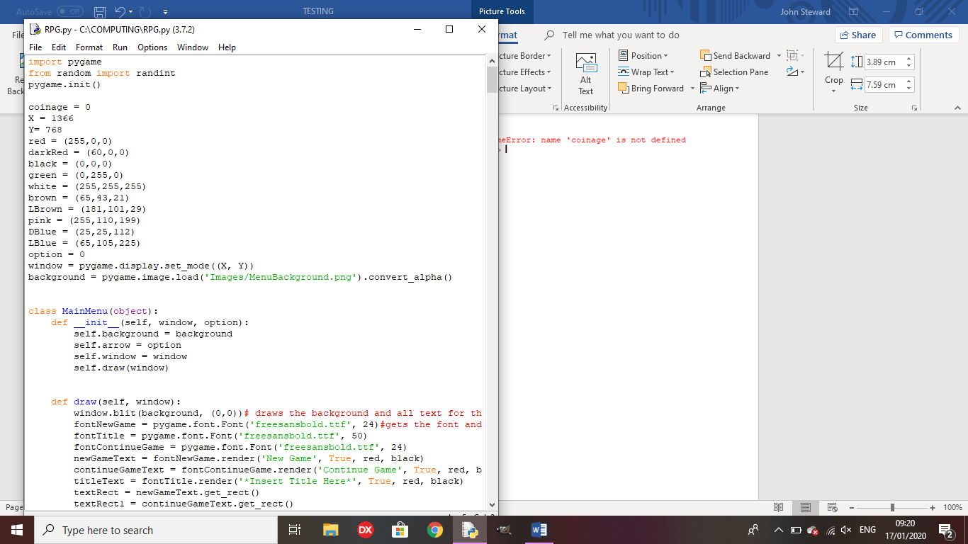

Test 23: Does the slot machine pay out if all 3 numbers are the same?

Outcome: The slot machine gives you 150 coins and a key item(on the first win)

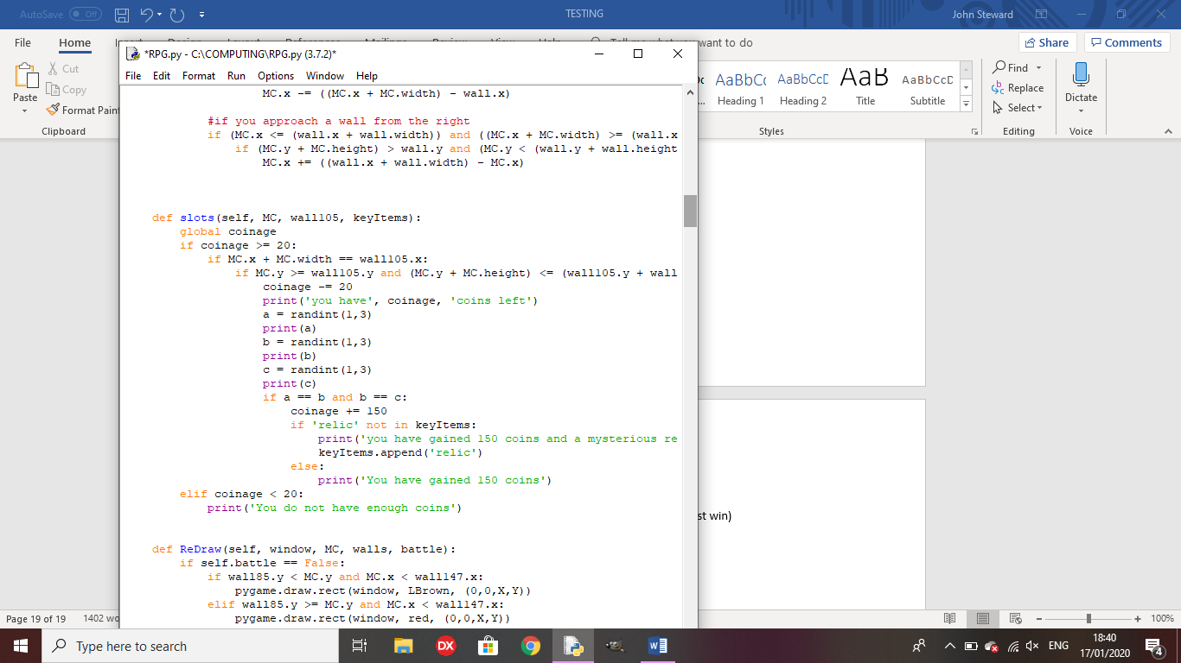

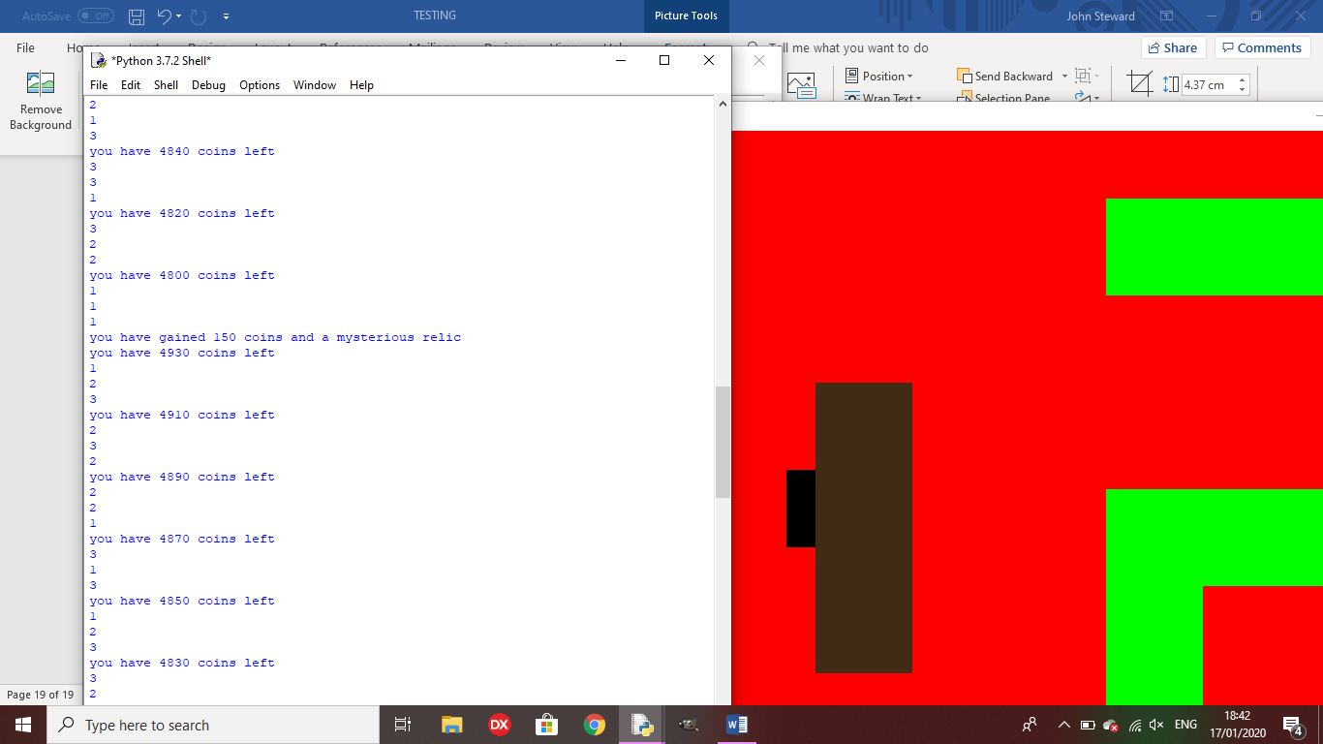

Test 24: If a character dies in battle, do they return with 1 health after the battle?

Outcome: They character has negative health but does not die.

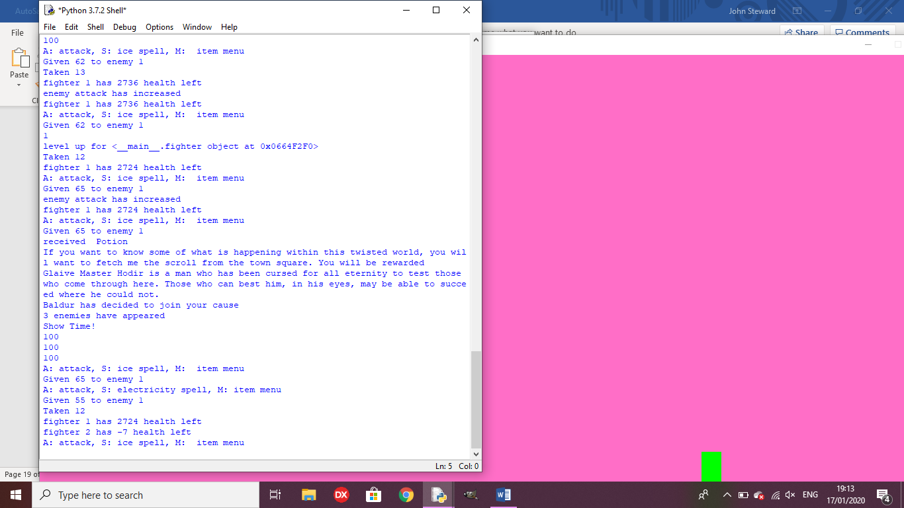

Remedy:

I altered the battle loop to kill the character when they got to below 0 health.

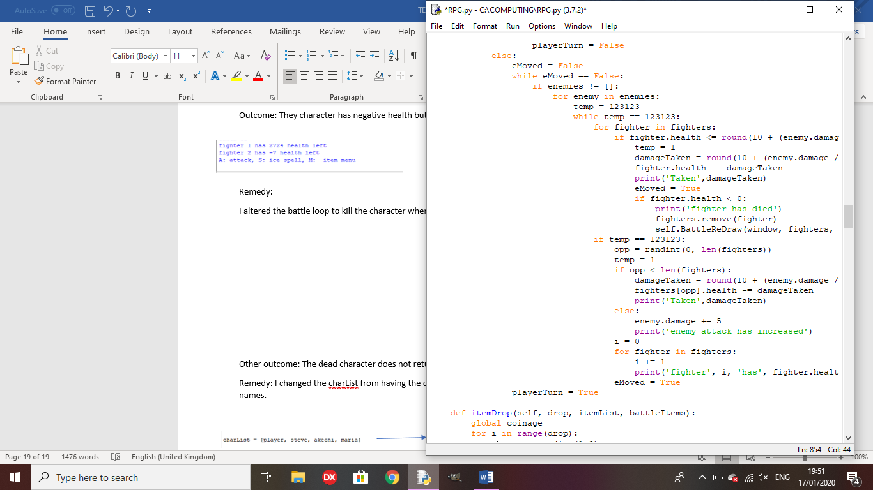

Other outcome: The dead character does not return once they have died.

Remedy: I changed the charList from having the objects in the list, to having strings with their names.

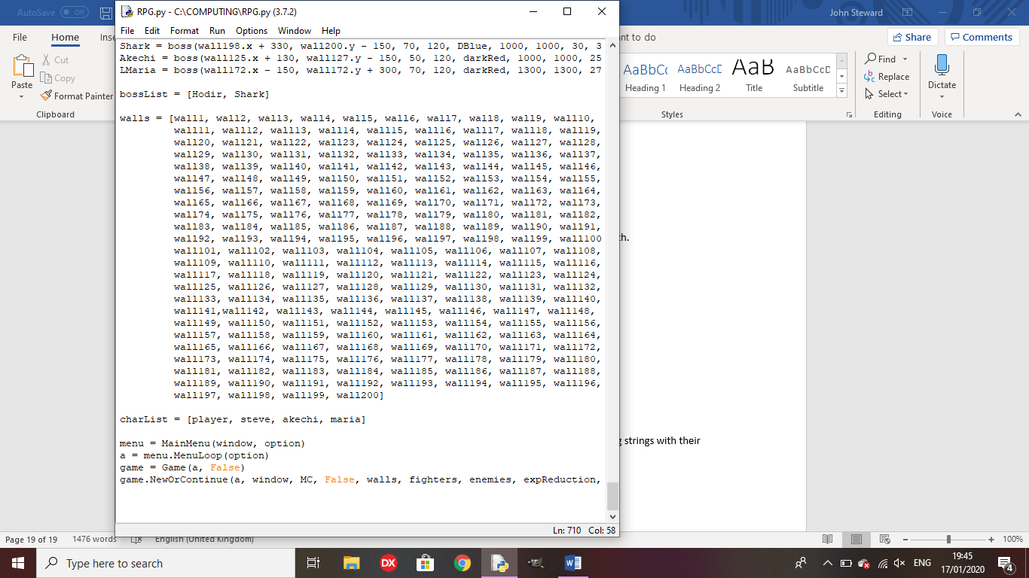

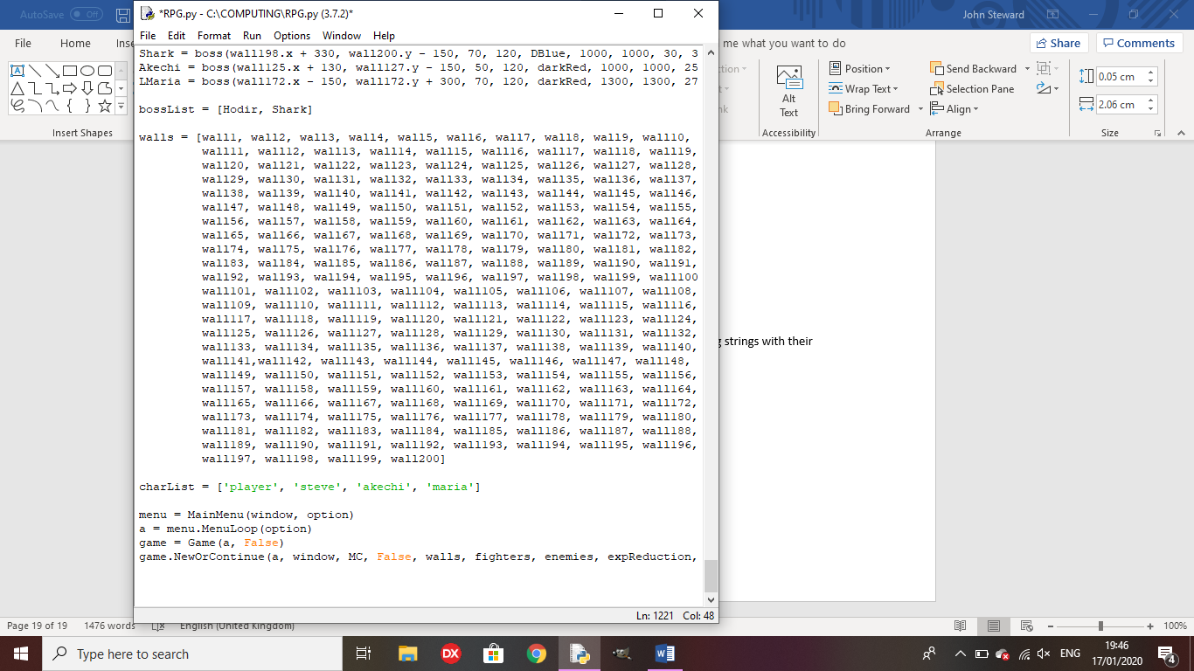

Test 24: Does the final boss trigger with separate endings based on completion?

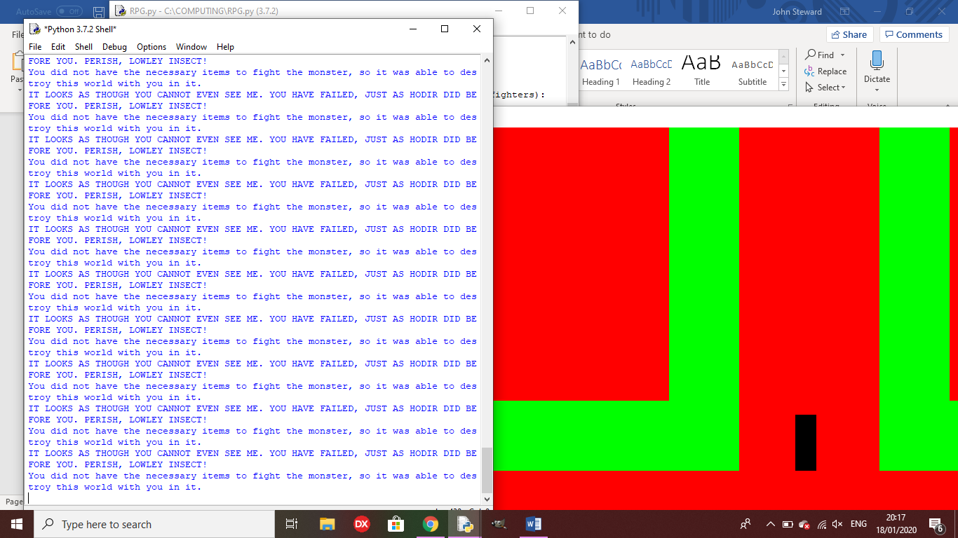Outcome: The first ending occurs how it should, but the game does not end.

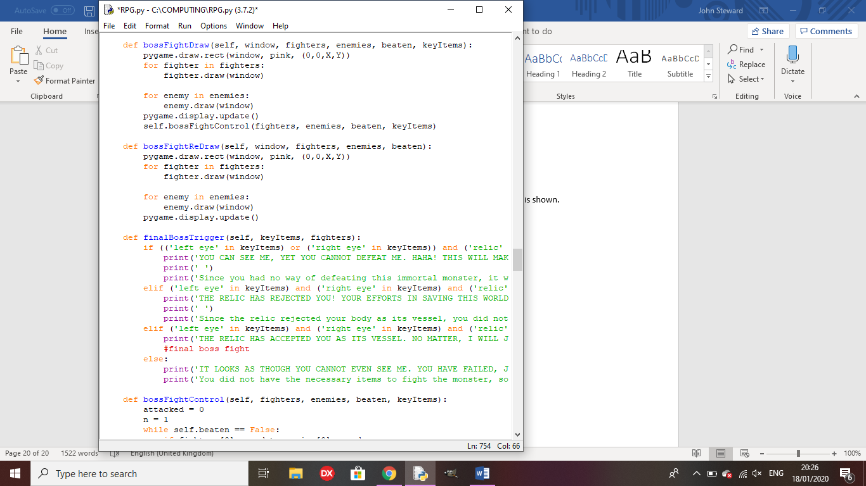

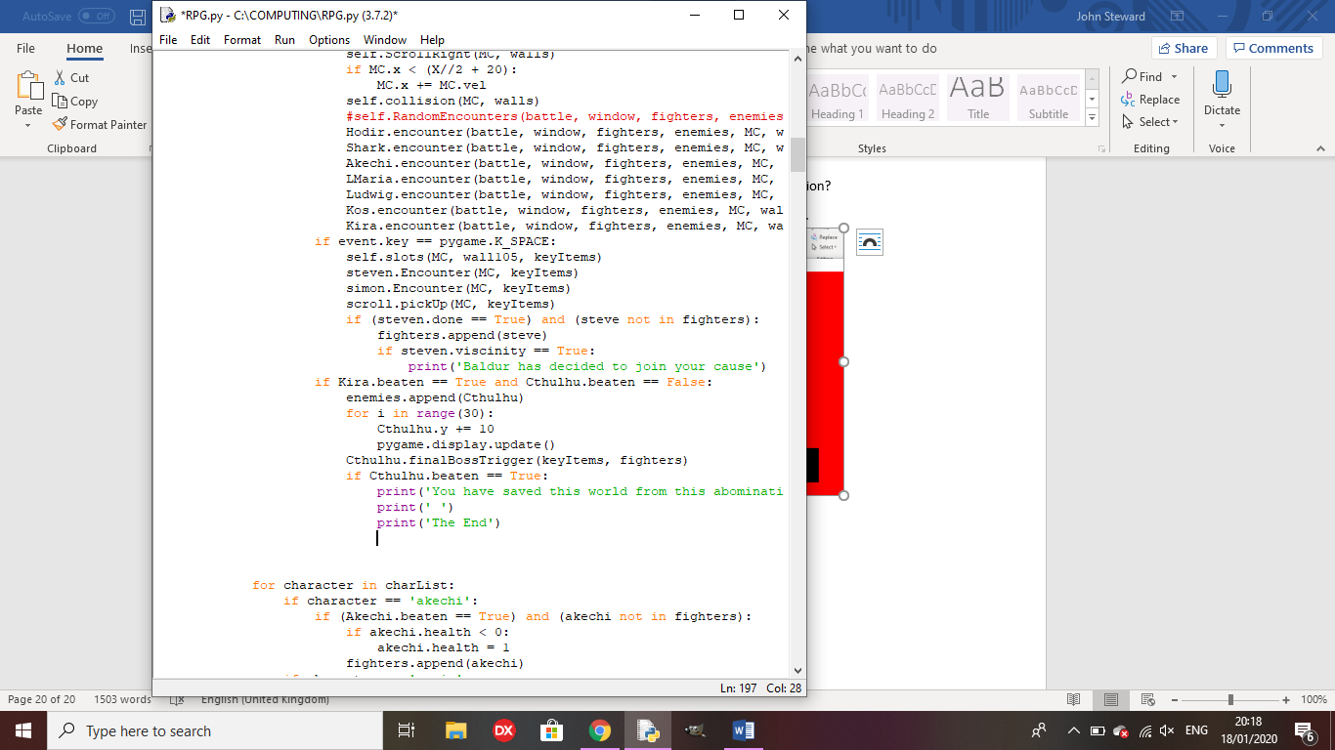

Remedy: I added something to the check, ending the game after the ending is shown.

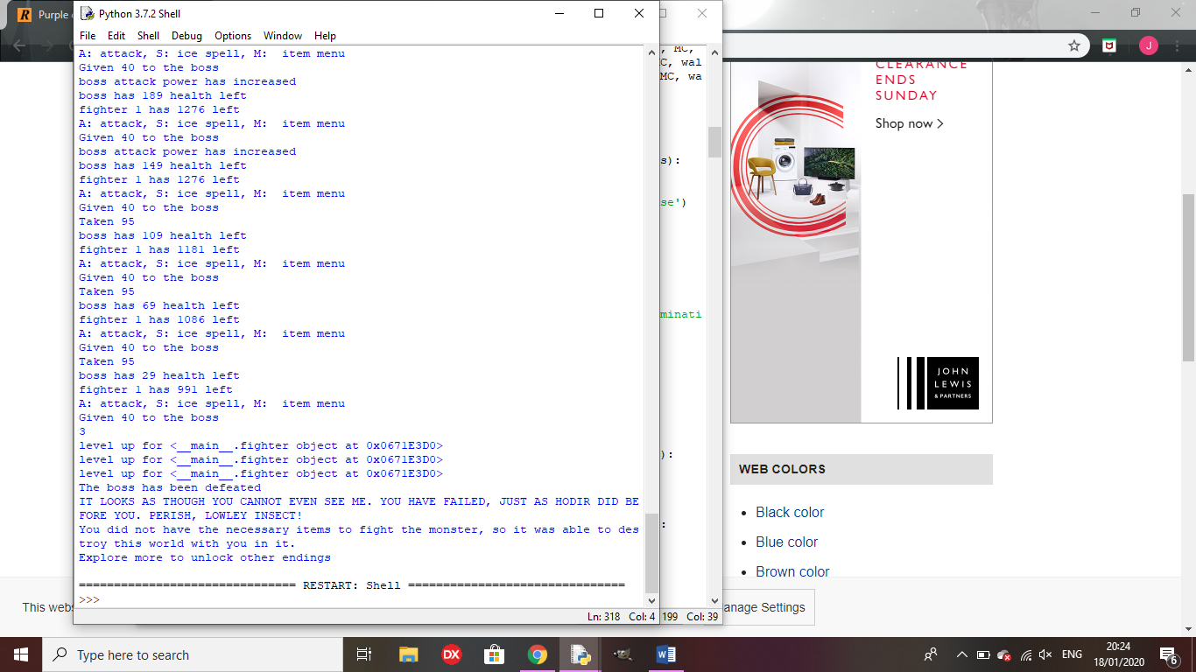

Outcome for ending 2: The first ending triggers instead of the second

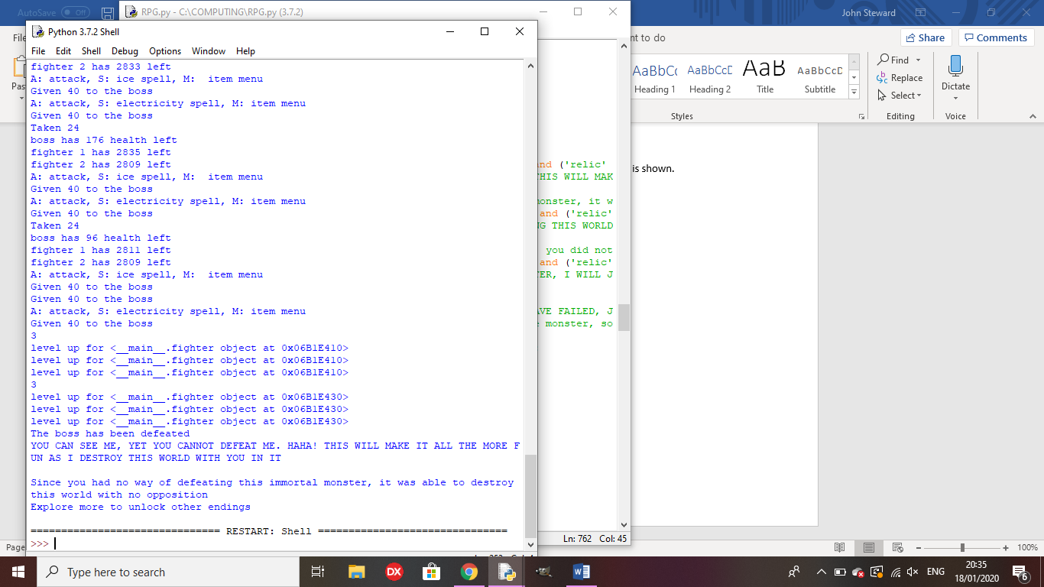Remedy: I altered the item names to be consistent.

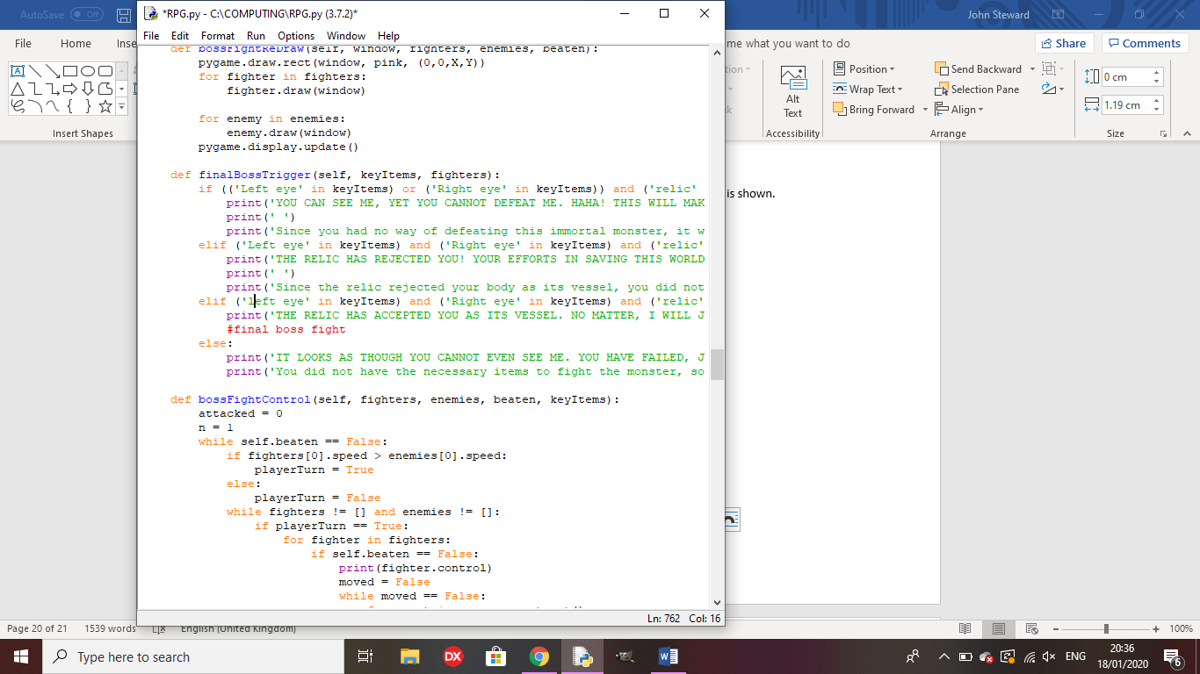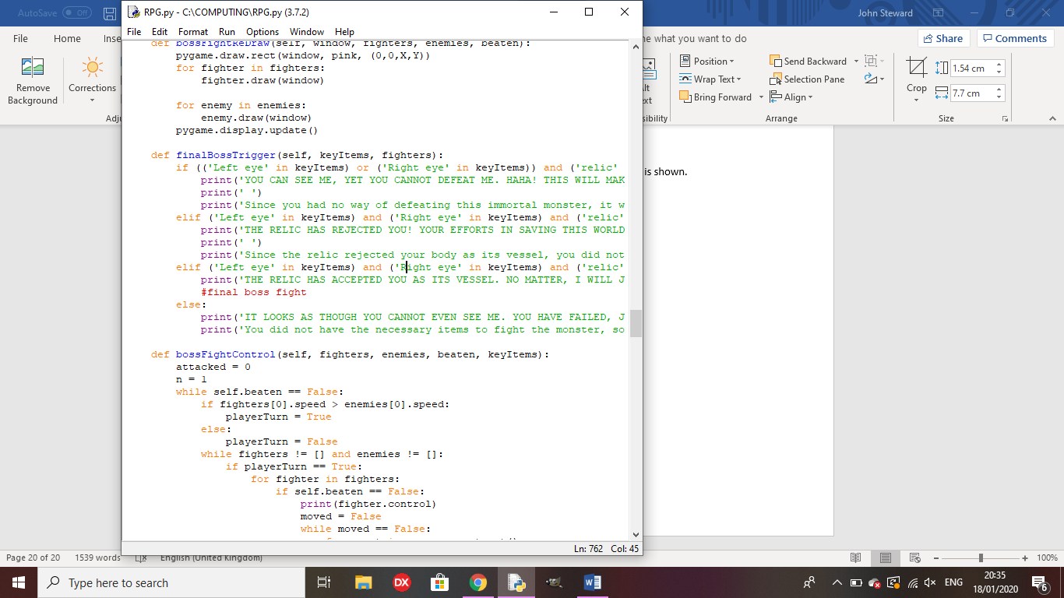

Outcome for 3rd ending: The first ending is played instead

Remedy: I altered the check for the third ending.

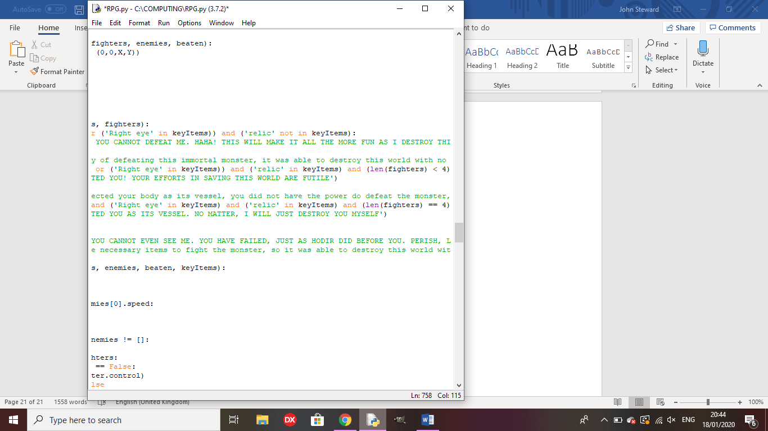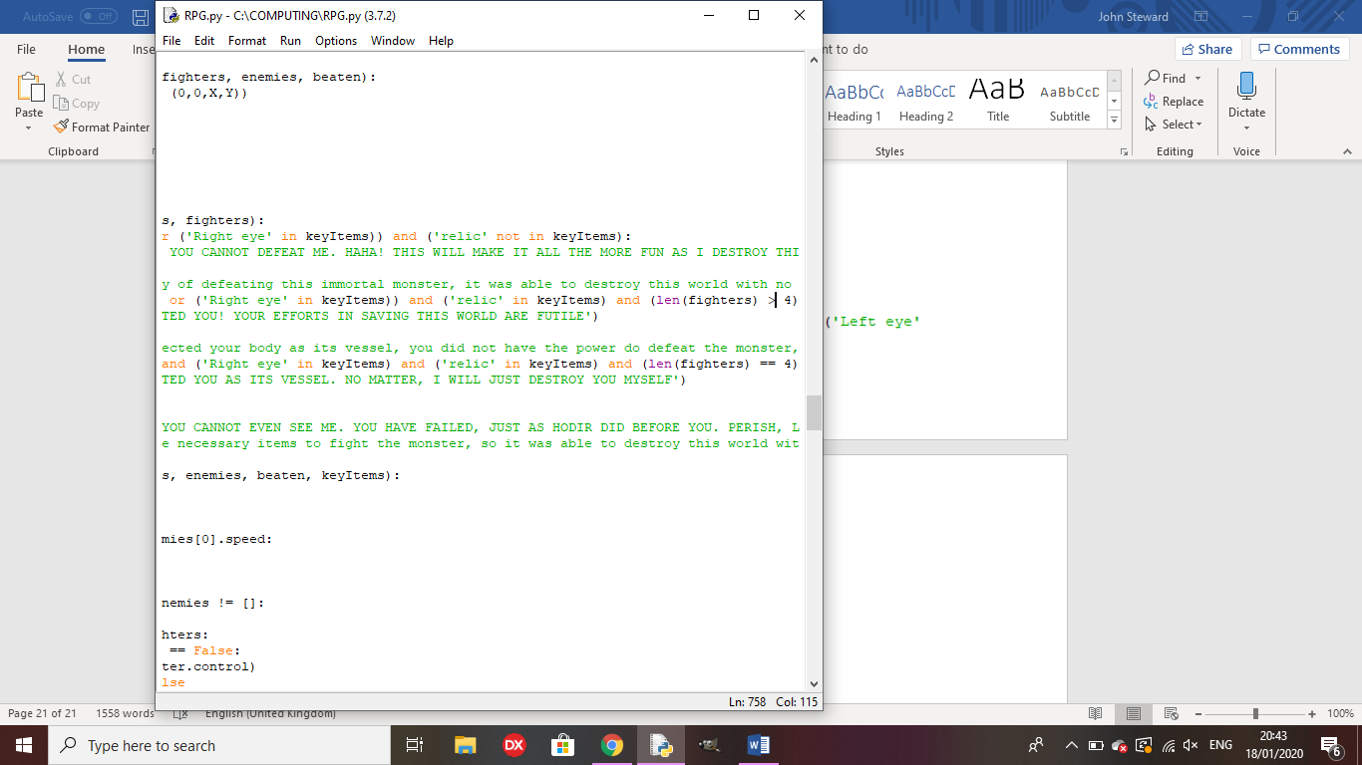

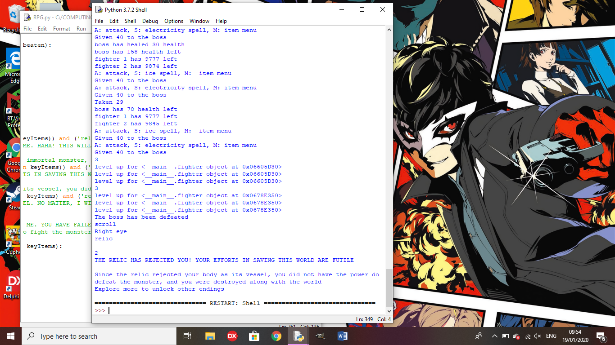

Outcome for true ending: The text shows but the final boss doesn’t trigger.

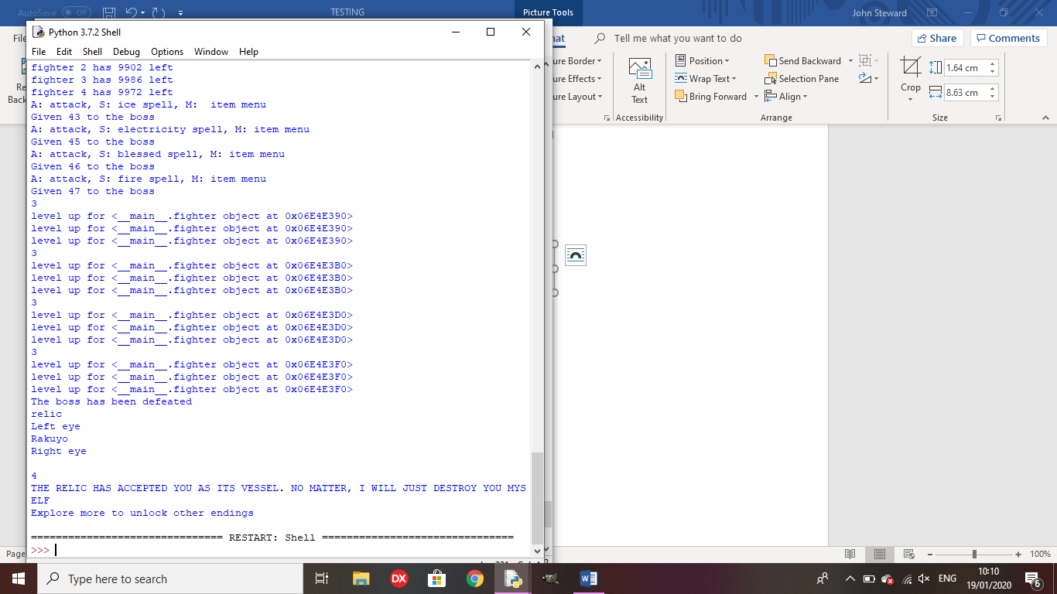

Remedy: I called the bossFightControl method in the true ending section of the finalBossTrigger method

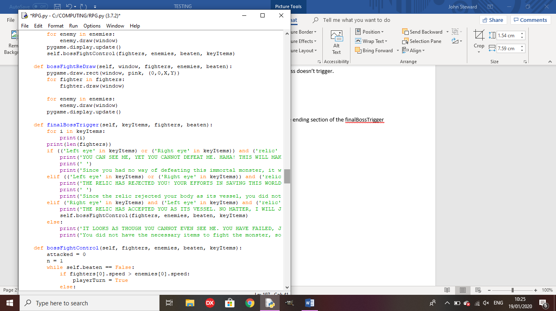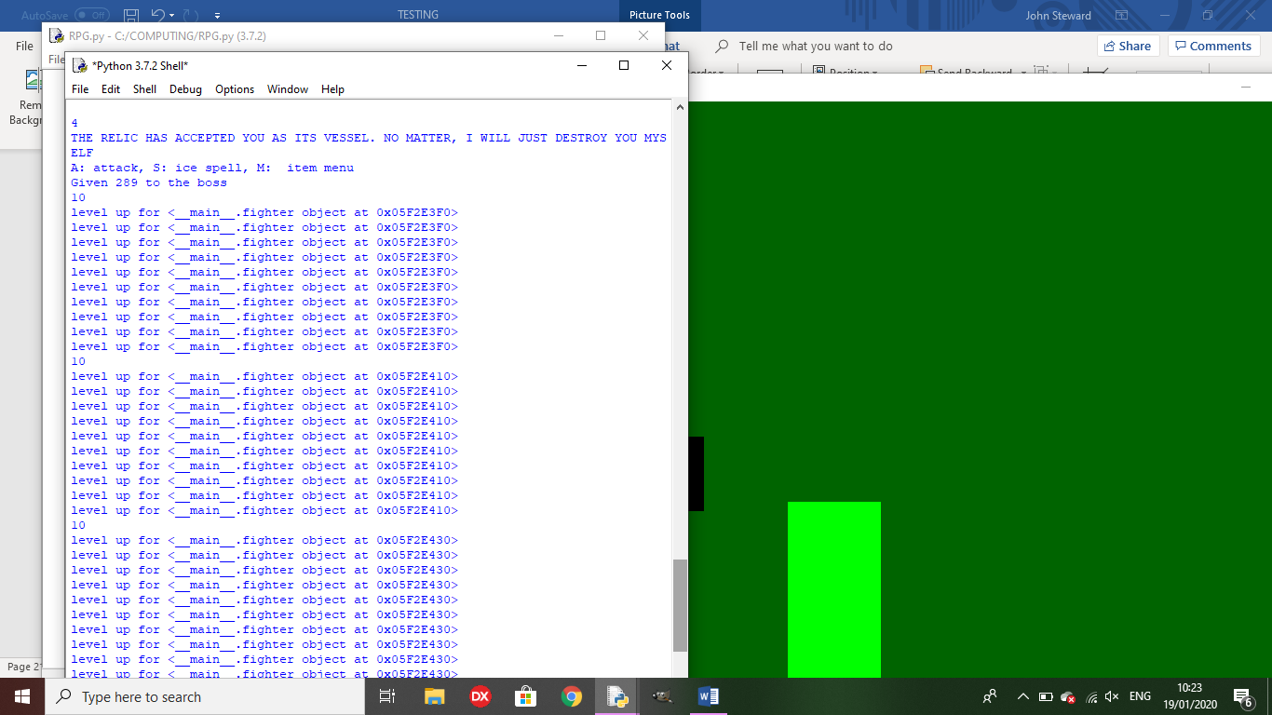

Test 25: does the game save variables to a text file?

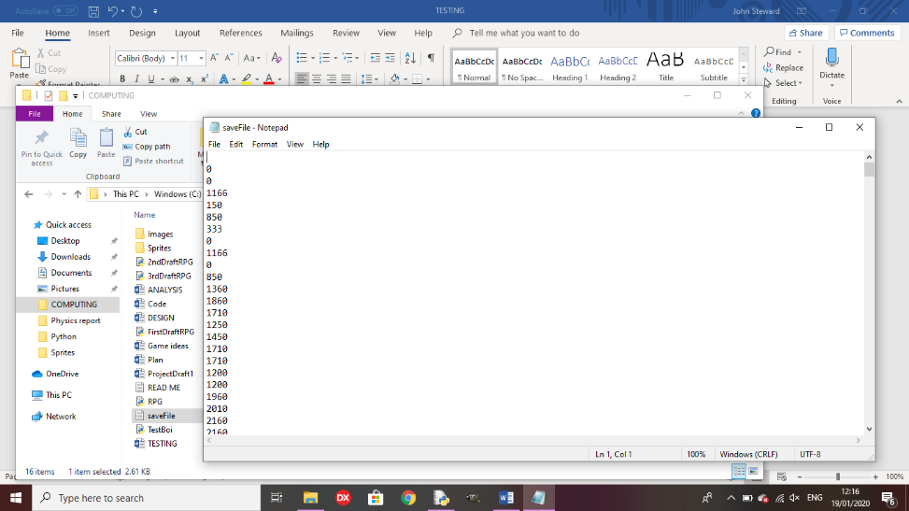Outcome: all variable that need to be saved are saved to a text file line-by-line.

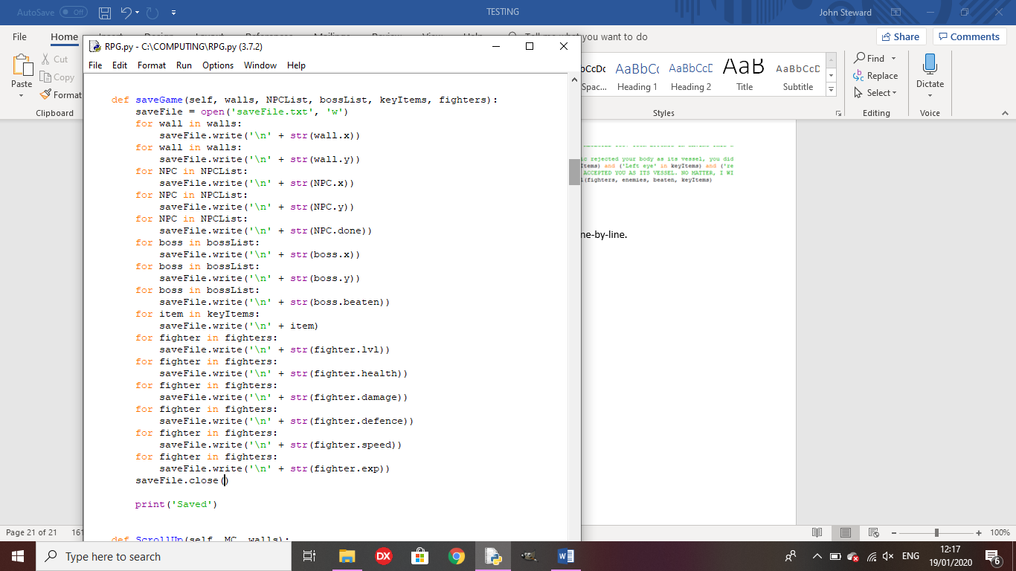

Test 26: If you press Continue game, does it get the variables from the text file and draw it in the same way as you last saved?

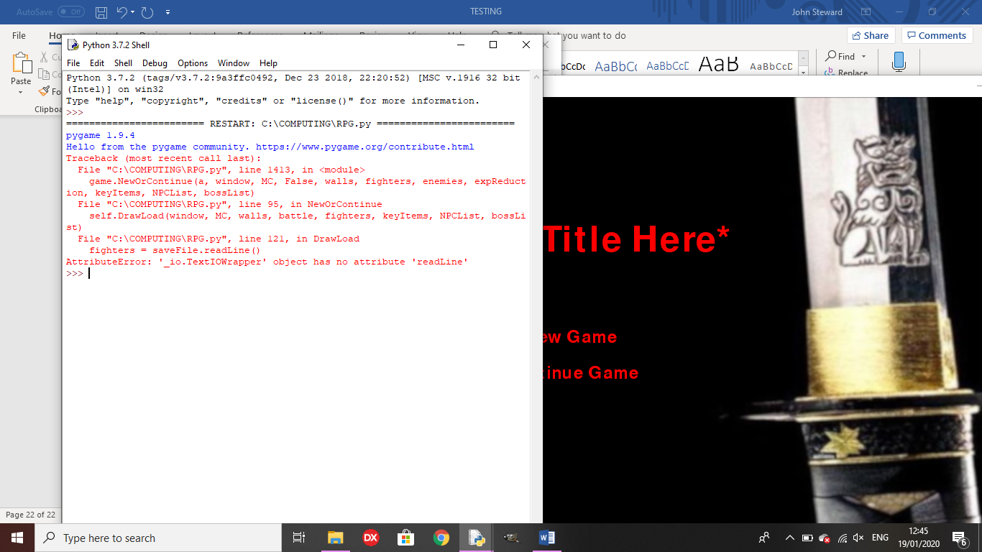Outcome: An error occurred.

Remedy: I changed ‘readLine’ to ‘readline’

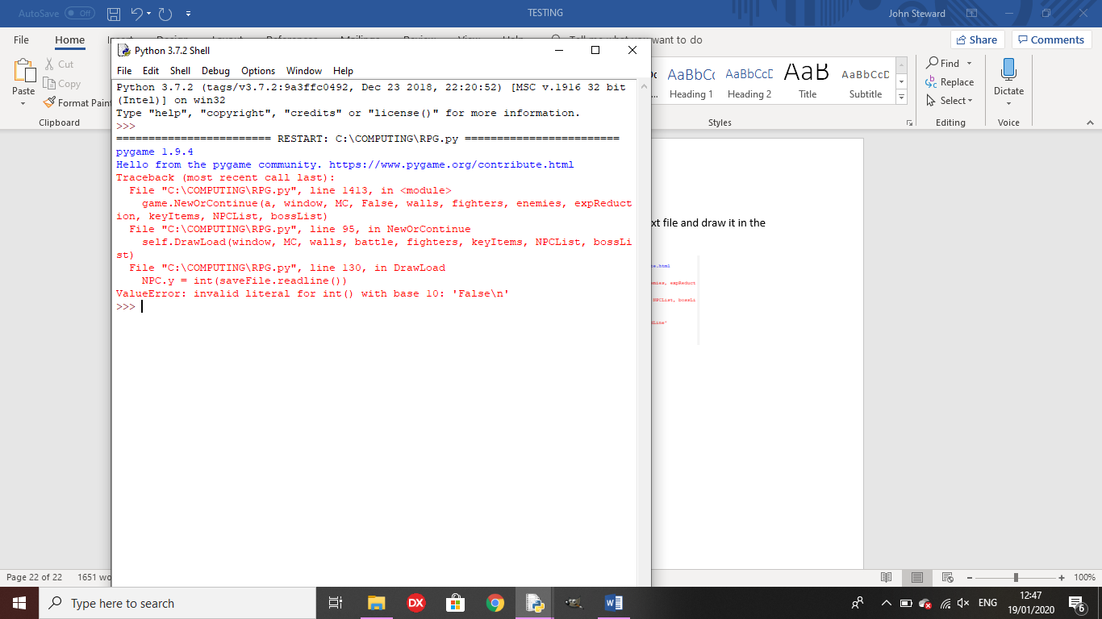Outcome 2:

Remedy: I only added characters to lists if they weren’t already in there, so they weren’t getting the wrong variables from the text file.

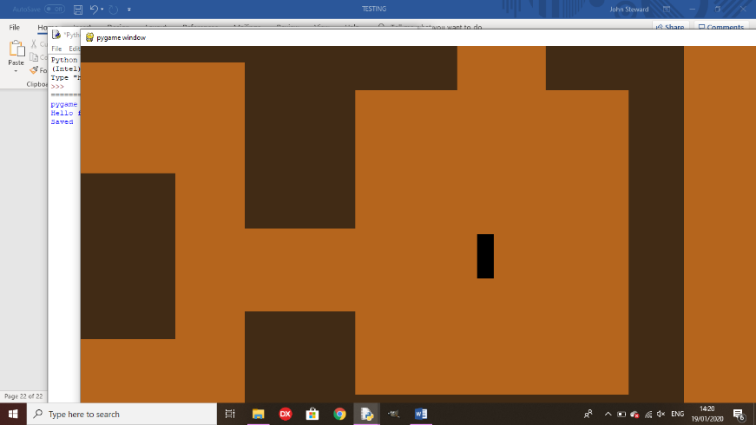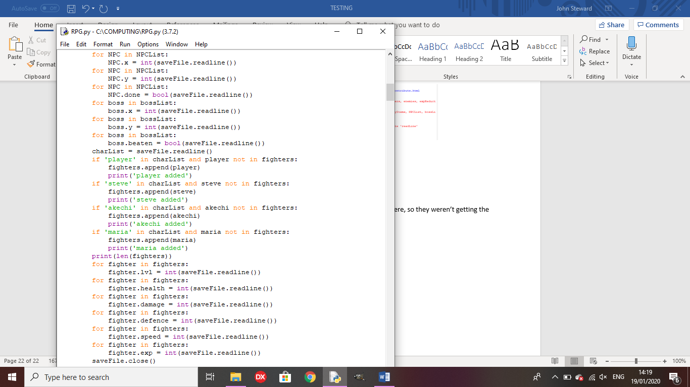

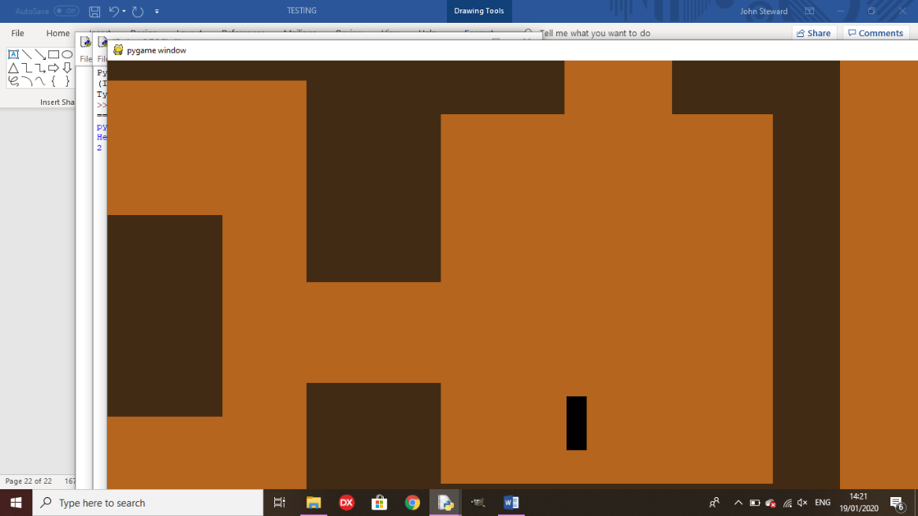

**Final Review**

All of the main features of the game now fully function, like boss encounters, the ‘Continue Game’ option and NPC side quests. Enemies can now buff their strength in battle and bosses can buff strength or defence, or they can heal themselves. The final boss now triggers one of four endings, based on the player’s key items list and the number of characters in their party.

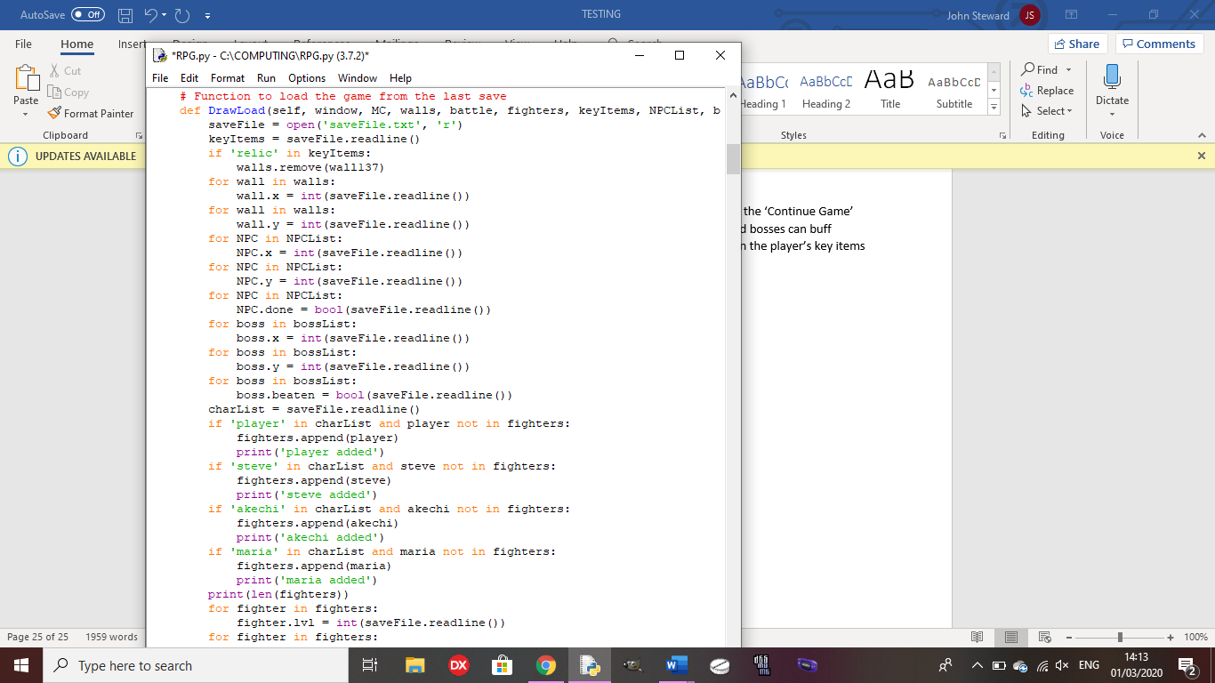

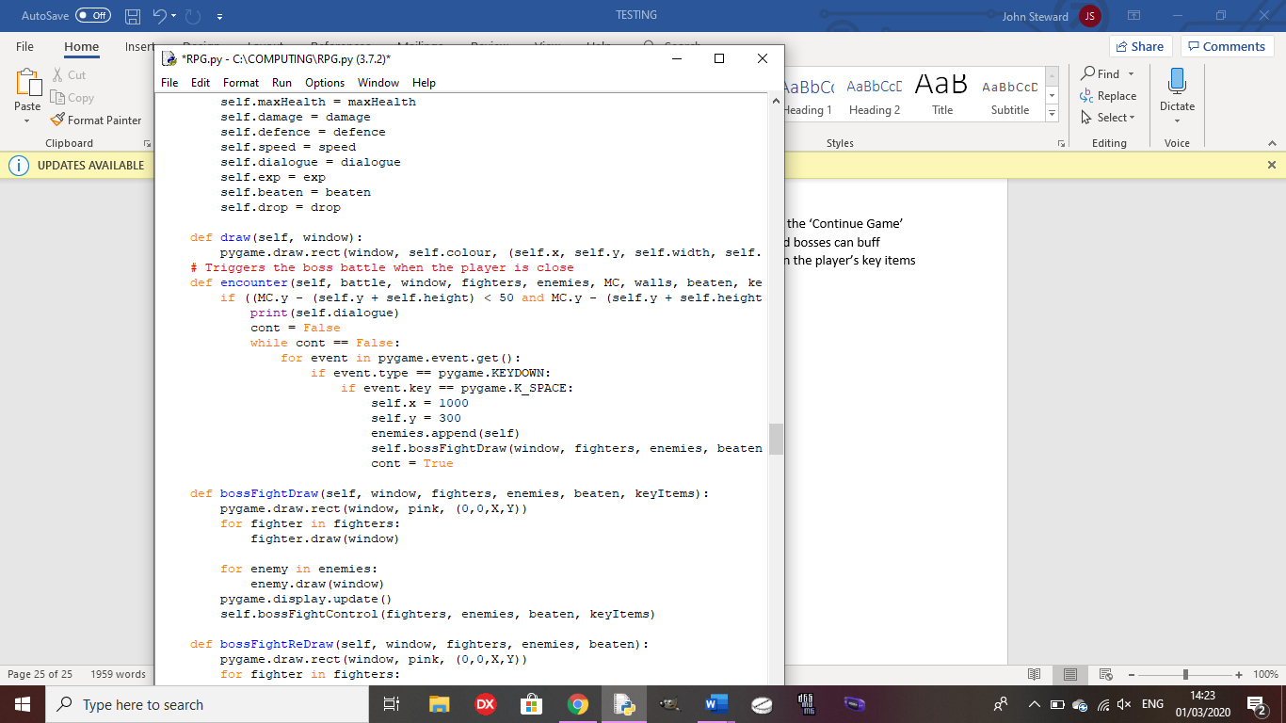



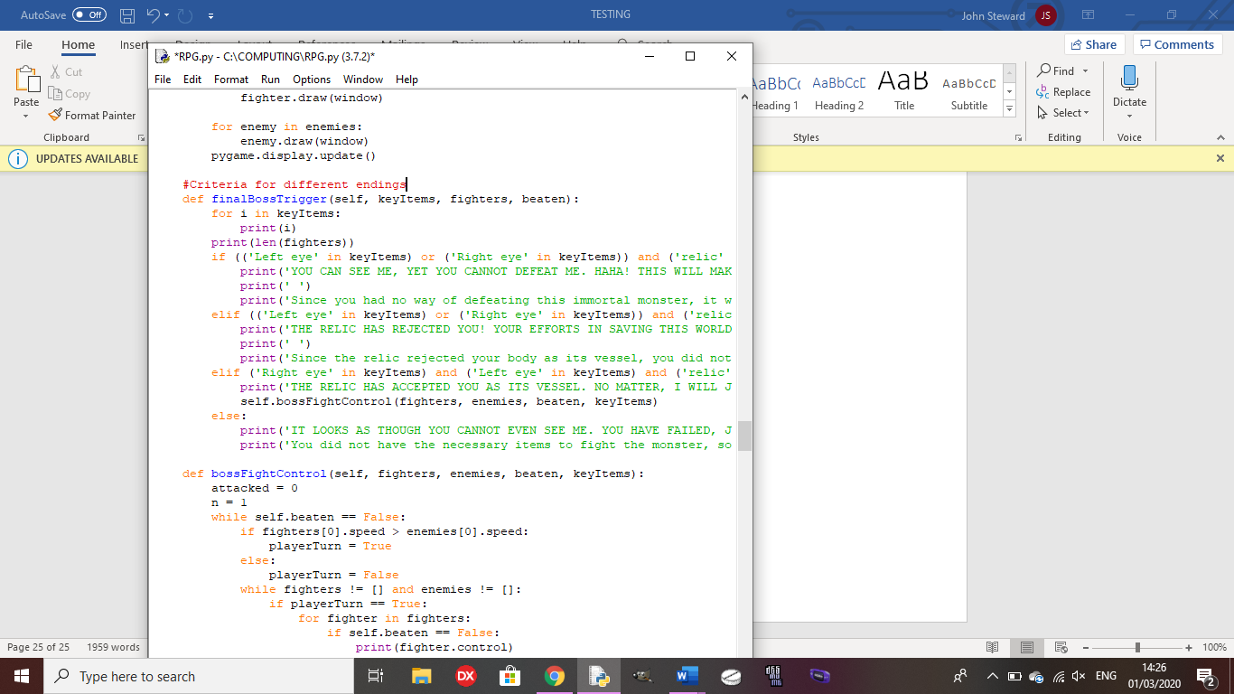

Using items in-battle:



